# VISVESVARAYA TECHNOLOGICAL UNIVERSITY

**“JnanaSangama”, Belgaum -590014, Karnataka.**



## LAB REPORT

### on

Machine Learning (23CS6PCMAL)

#### Submitted by

**AGAM TIWARI (1BM22CS023)**

#### in partial fulfillment for the award of the degree of

**BACHELOR OF ENGINEERING**

***in***

## COMPUTER SCIENCE AND ENGINEERING



**B.M.S. COLLEGE OF ENGINEERING**

**(Autonomous Institution under VTU)**

## BENGALURU-560019

## Sep-2024 to Jan-2025

**B.M.S. College of Engineering,**

**Bull Temple Road, Bangalore 560019**

(Affiliated To Visvesvaraya Technological University, Belgaum)

**Department of Computer Science and Engineering**



##### CERTIFICATE

This is to certify that the Lab work entitled “Machine Learning (23CS6PCMAL)” carried out by **Agam Tiwari (1BM22CS023),** who is bonafide student of **B.M.S. College of Engineering.** It is in partial fulfillment for the award of **Bachelor of Engineering in Computer Science and Engineering** of the Visvesvaraya Technological University, Belgaum. The Lab report has been approved as it satisfies the academic requirements in respect of an Machine Learning (23CS6PCMAL) work prescribed for the said degree.

Dr. Kavitha Sooda Professor & HOD

Department of CSE, BMSCE

Seema Patil

Assistant Professor Department of CSE, BMSCE

# Index

|  |  |  |  |
| --- | --- | --- | --- |
| **Sl.**  **No.** | **Date** | **Experiment Title** | **Page No.** |
| 1 | 4-3-2025 | Write a python program to import and export data using Pandas library functions | 2-6 |
| 2 | 11-3-2025 | Demonstrate various data pre-processing techniques for a given dataset | 7-9 |
| 3 | 18-3-2025 | Use an appropriate data set for building the decision tree (ID3) and apply this knowledge to classify a new sample. | 10-16 |
| 4 | 1-4-2025 | Implement Linear and Multi-Linear Regression algorithm using appropriate dataset | 17-24 |
| 5 | 8-4-2025 | Build Logistic Regression Model for a given dataset | 25-29 |
| 6 | 15-4-2025 | Build KNN Classification model for a given dataset. | 30-34 |
| 7 | 15-4-2025 | Build Support vector machine model for a given dataset | 35-43 |
| 8 | 22-4-2025 | Implement Random forest ensemble method on a given dataset. | 44-47 |
| 9 | 22-4-2025 | Implement Boosting ensemble method on a given dataset. | 48-50 |
| 10 | 29-4-2025 | Build k-Means algorithm to cluster a set of data stored in a .CSV file. | 51-54 |
| 11 | 29-4-2025 | Implement Dimensionality reduction using Principal Component Analysis (PCA) method. | 55-60 |

Github Link:

<https://github.com/Agam1611/ML-Lab>

**Program 1**

**Write a python program to import and export data using Pandas library functions**

**Screenshot:**

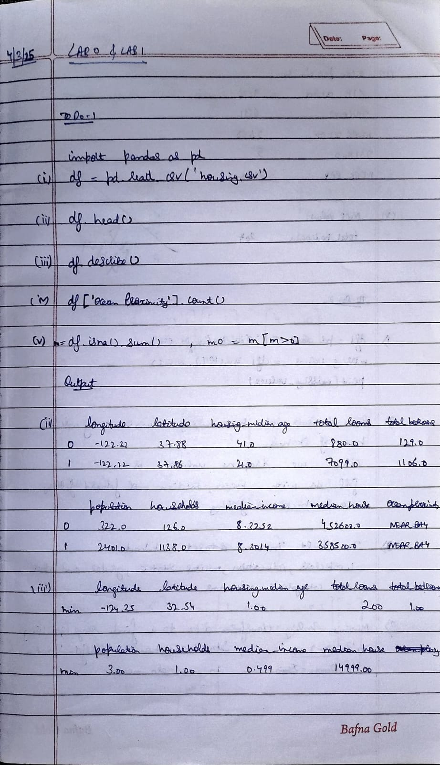

**Code:**

import pandas as pd

data = {

'USN':[22,23,24,30,11],

'Name':['Aditya Singh','Agam Tiwari','Agneya','Akshat','Adarsh'],

'Marks':[90,97,99,91,92]

}

df = pd.DataFrame(data)

print("Sample data:")

print(df.head())

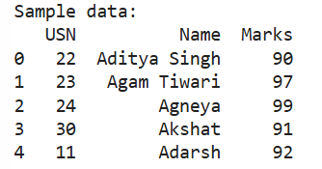

from sklearn.datasets import load_diabetes

dib = load_diabetes()

df = pd.DataFrame(dib.data, columns=dib.feature_names)

# df['target'] = dib.target

print("Sample data:")

print(df.head())

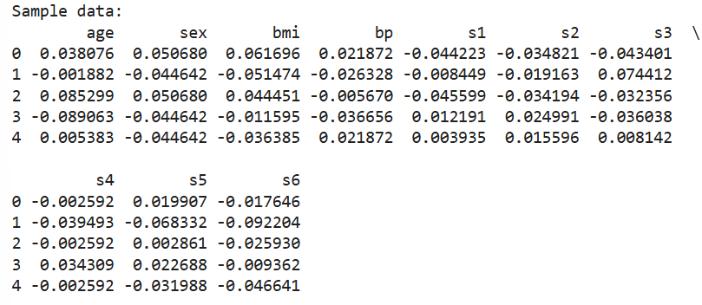

file_path = 'data.csv' # Ensure the file exists in the same directory

df = pd.read_csv(file_path)

print("Sample data:")

print(df.head())

print("\n")

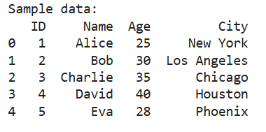

import yfinance as yf

import pandas as pd

import matplotlib.pyplot as plt

tickers = ["HDFCBANK.NS", "ICICIBANK.NS", "KOTAKBANK.NS"]

data = yf.download(tickers, start="2024-01-01", end="2024-12-30",group_by='ticker')

print("\n\n\nFirst 5 rows of the dataset:")

print(data.head())

print("\nShape of the dataset:")

print(data.shape)

print("\nColumn names:")

print(data.columns)

hdfcData= data["HDFCBANK.NS"]

hdfcData['Daily Return'] = hdfcData['Close'].pct_change()

plt.figure(figsize=(12, 6))

plt.subplot(2, 1, 1)

hdfcData['Close'].plot(title="HDFC - Closing Price")

plt.subplot(2, 1, 2)

hdfcData['Daily Return'].plot(title="HDFC - Daily Returns", color='orange')

plt.tight_layout()

plt.show()

#2

iciciData= data["ICICIBANK.NS"]

iciciData['Daily Return'] = iciciData['Close'].pct_change()

plt.figure(figsize=(12, 6))

plt.subplot(2, 1, 1)

iciciData['Close'].plot(title="ICICI - Closing Price")

plt.subplot(2, 1, 2)

iciciData['Daily Return'].plot(title="ICICI - Daily Returns", color='orange')

plt.tight_layout()

plt.show()

#3

kotakData= data["KOTAKBANK.NS"]

kotakData['Daily Return'] = kotakData['Close'].pct_change()

plt.figure(figsize=(12, 6))

plt.subplot(2, 1, 1)

kotakData['Close'].plot(title="KOTAK - Closing Price")

plt.subplot(2, 1, 2)

kotakData['Daily Return'].plot(title="KOTAK - Daily Returns", color='orange')

plt.tight_layout()

plt.show()

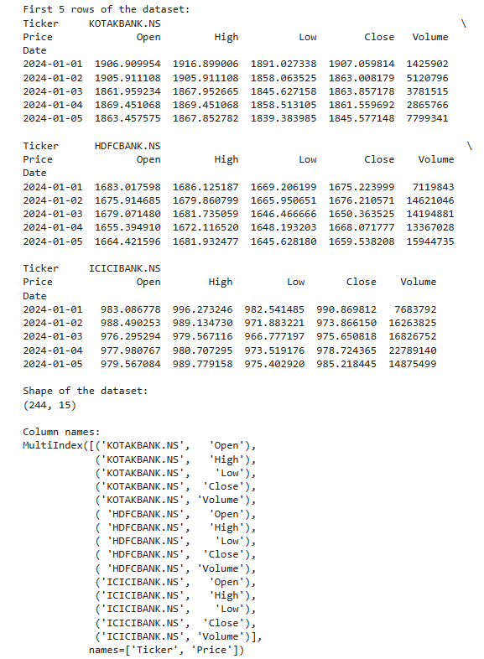

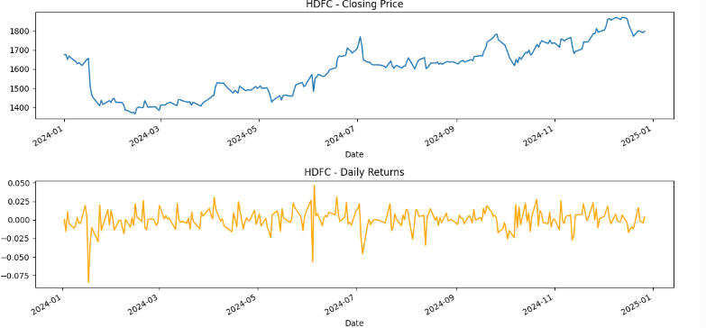

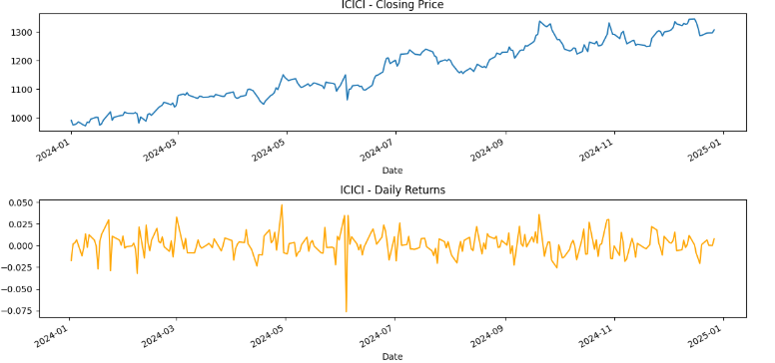

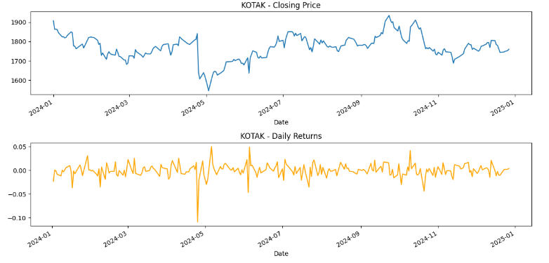

**Program 2**

**Demonstrate various data pre-processing techniques for a given dataset**

**Screenshot:**

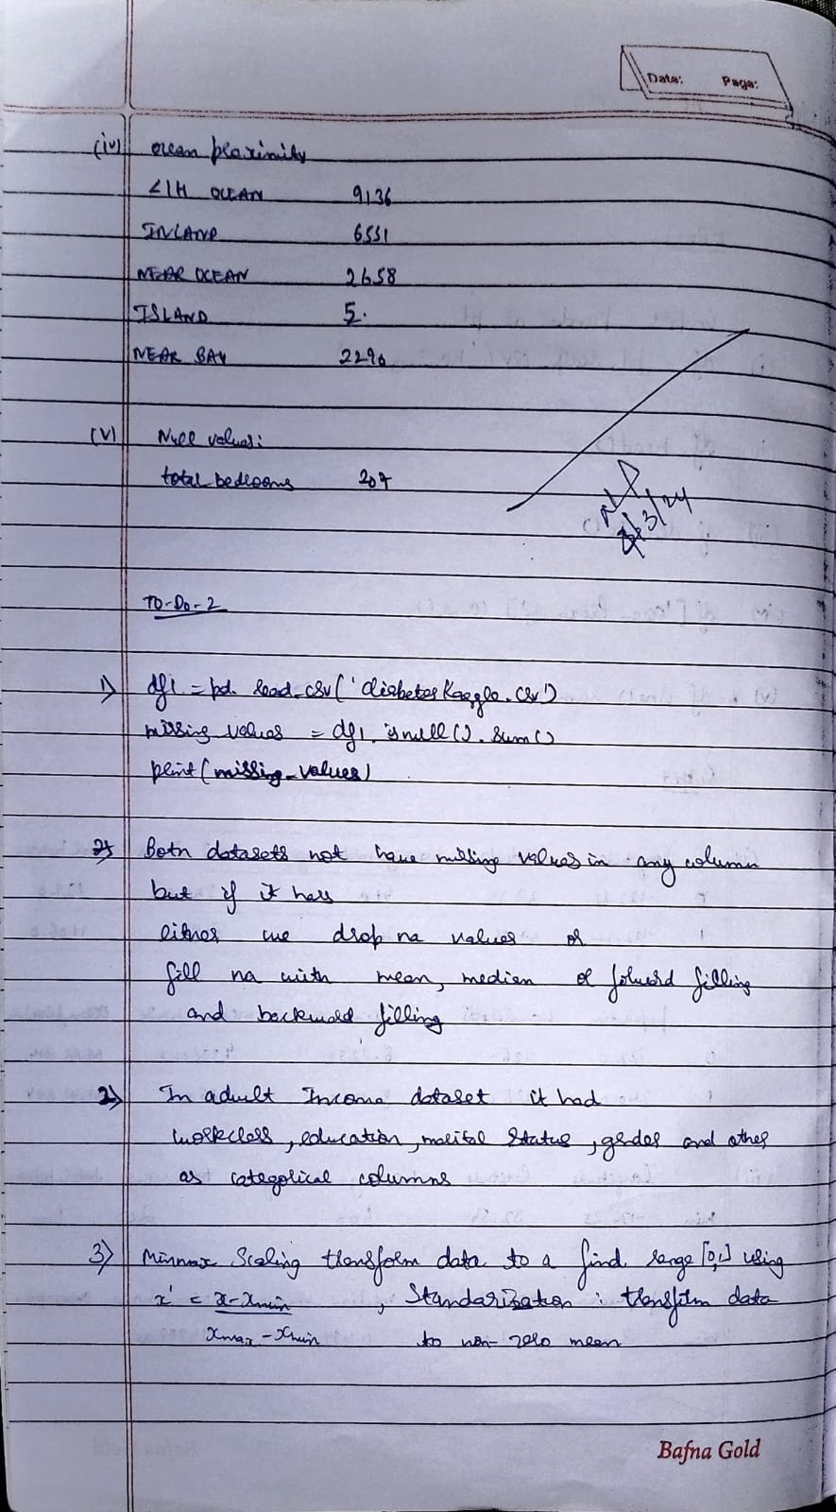

**Code:**

import pandas as pd

df = pd.read_csv('housing.csv')

print(df.head())

print(df.describe())

print("\ncount of unique labels for “Ocean Proximity” column")

print(df['ocean_proximity'].count())

print("Null Values : ")

miss = df.isna().sum()

miss0 = miss[miss>0]

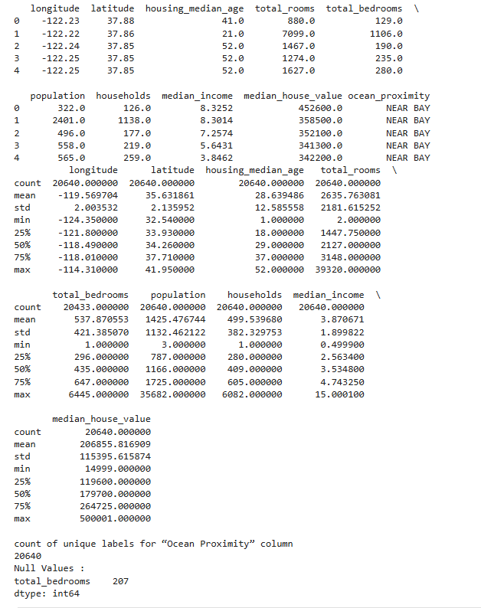

*#adult income dataset*

df2 = pd.read_csv('adult.csv')

missing_values = df2.isnull().sum()

print(missing_values)

print(df2.head())

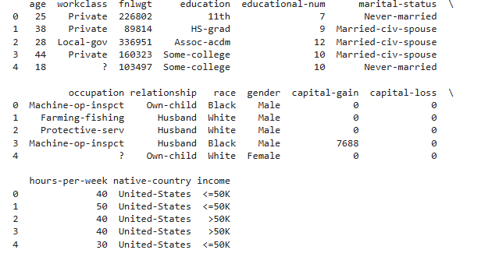

**Program 3**

**Implement Linear and Multi-Linear Regression algorithm using appropriate dataset**

**Screenshot:**

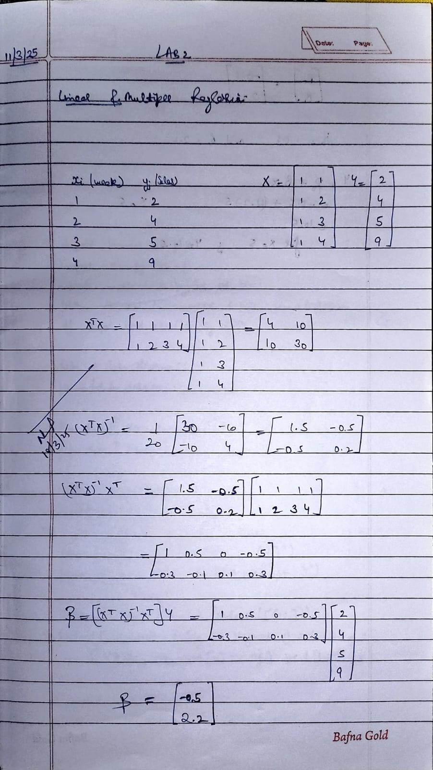

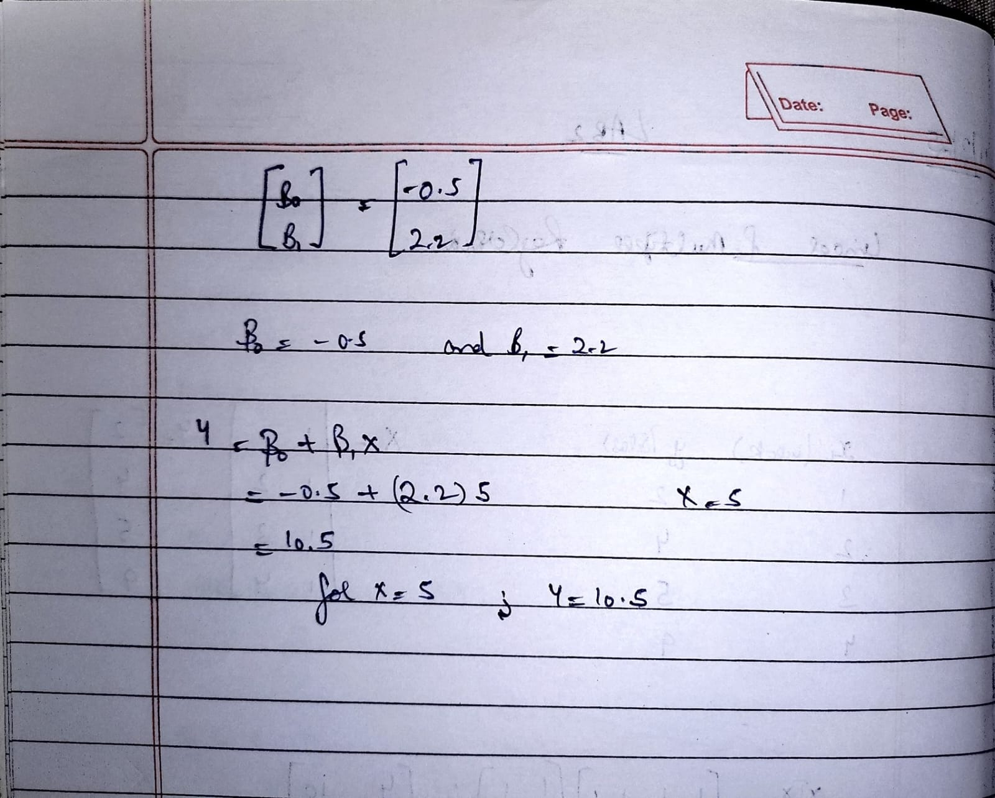

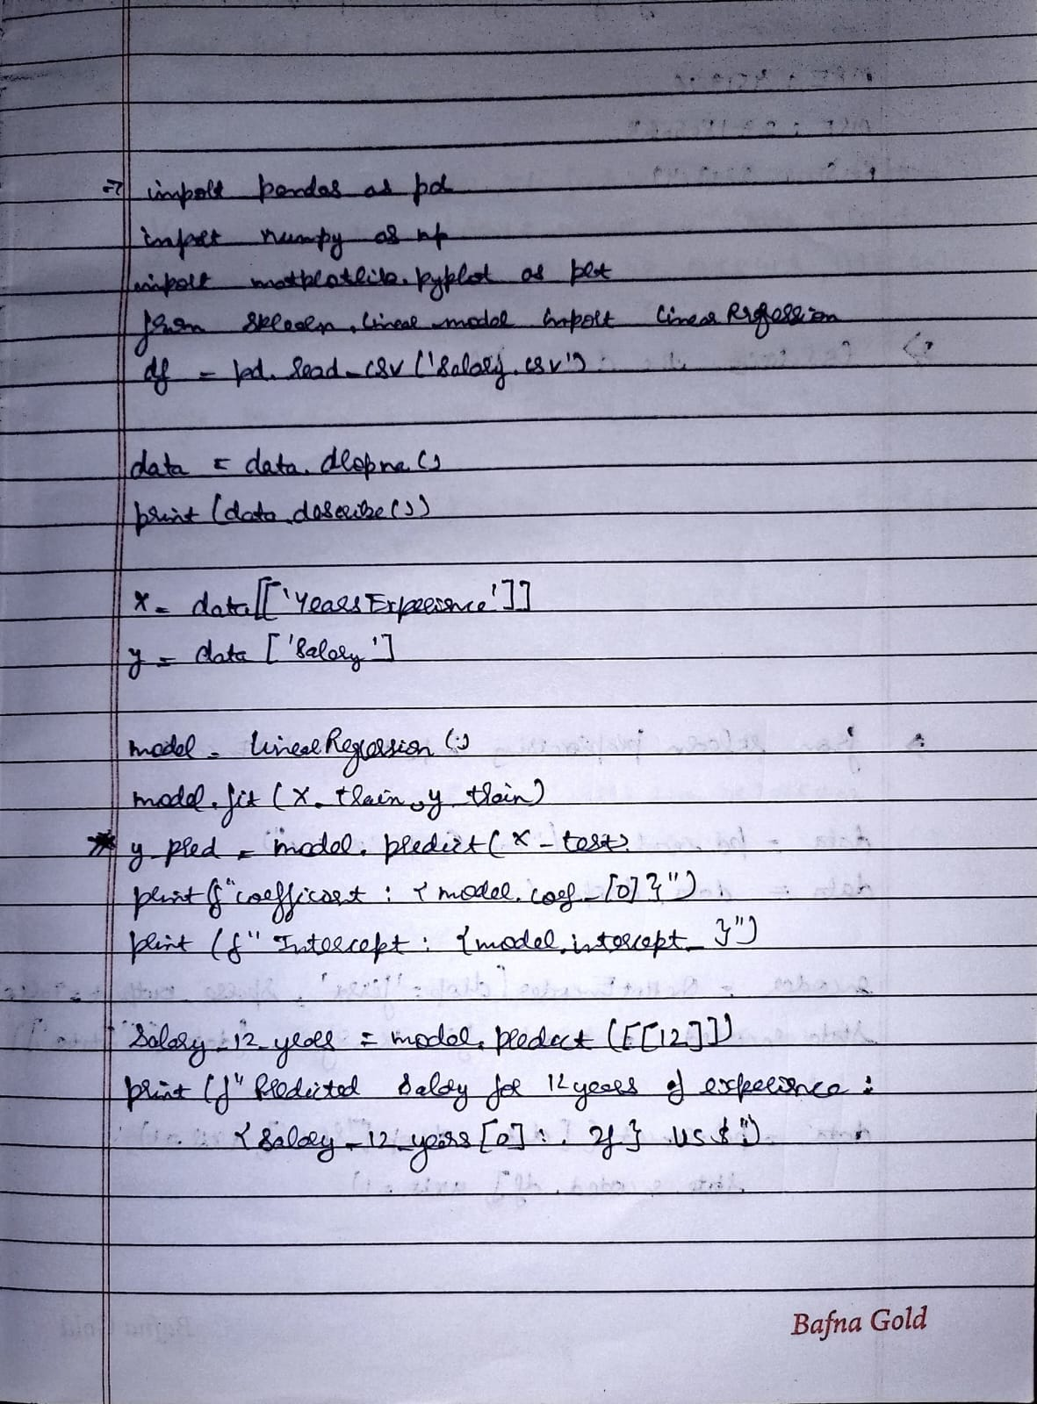

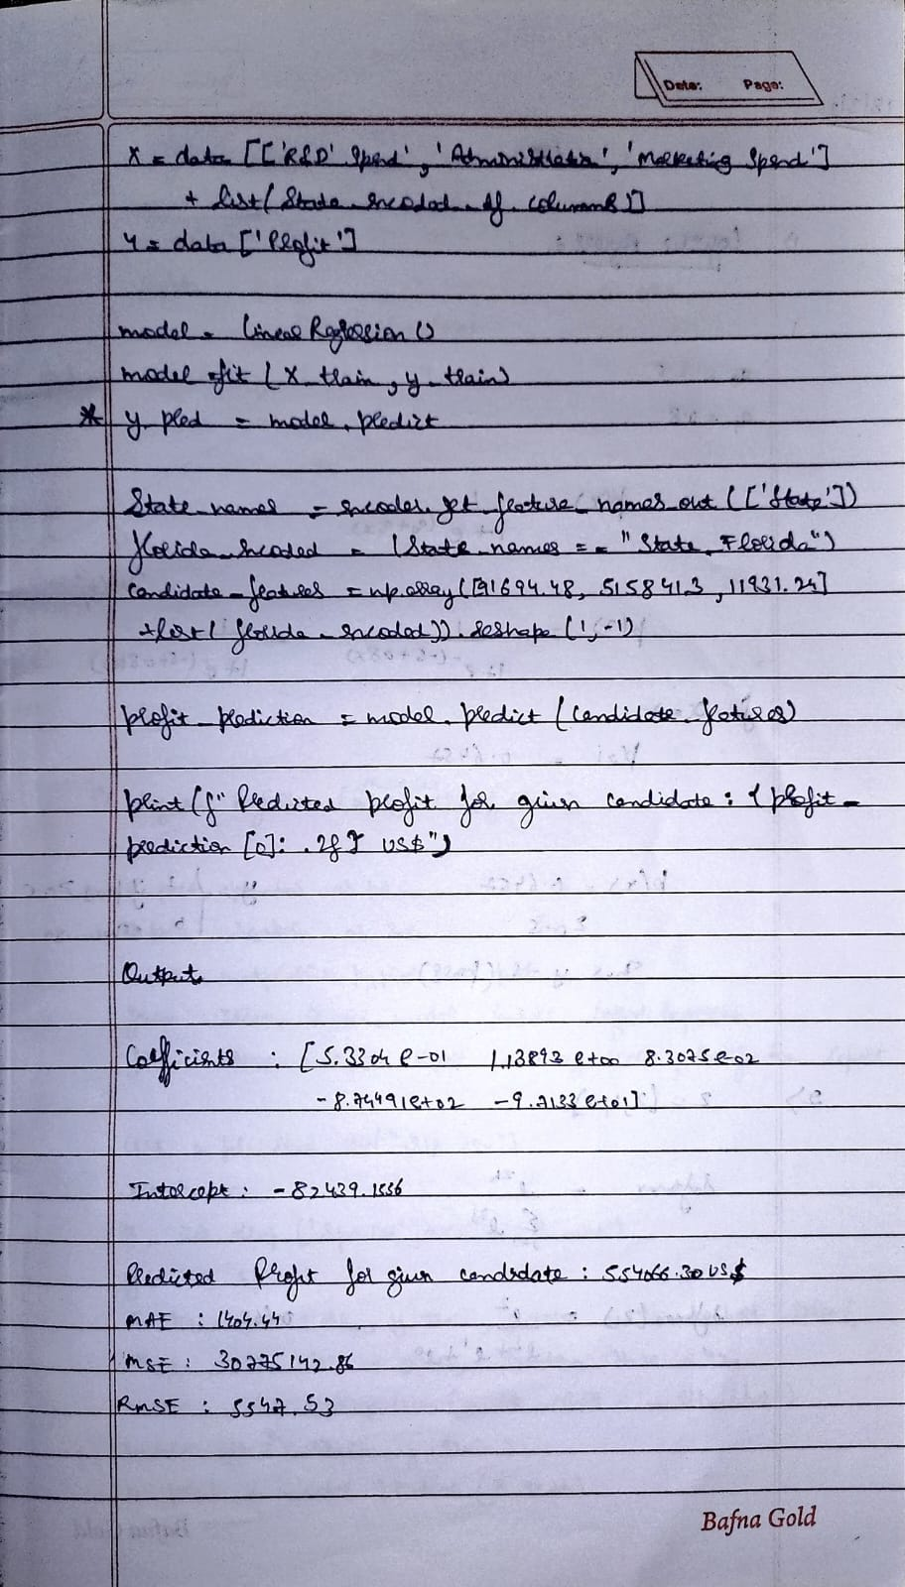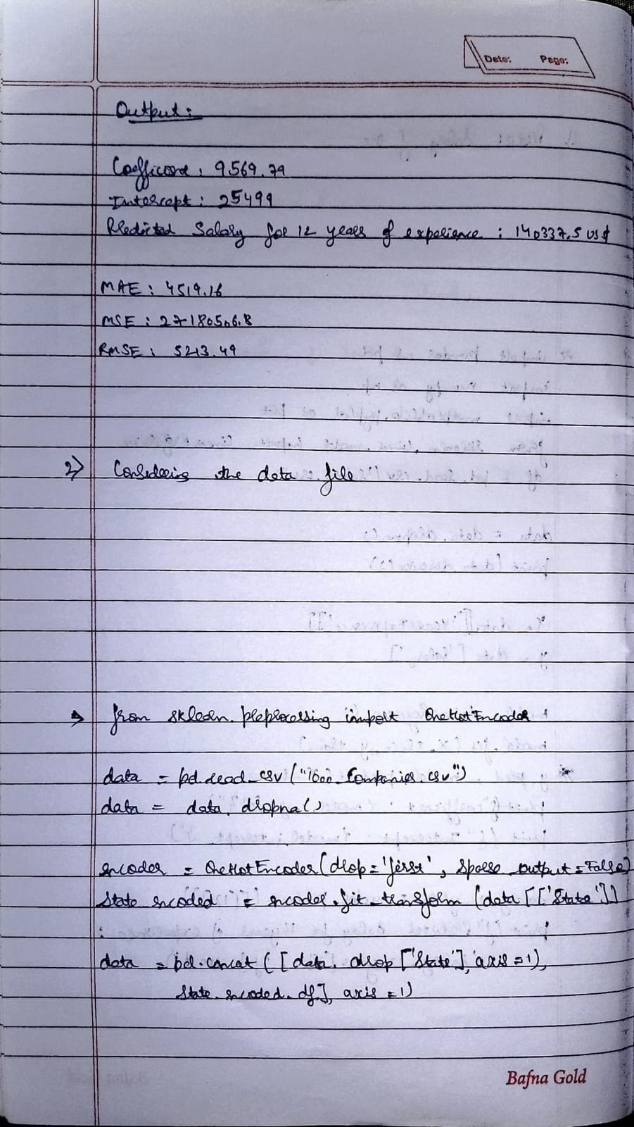

**Code:**

**Linear Regression:**

import pandas as pd

import numpy as np

import matplotlib.pyplot as plt

from sklearn.model_selection import train_test_split

from sklearn.linear_model import LinearRegression

data = pd.read_csv("canada_per_capita_income.csv")

# Analyze data distribution

print(data.describe())

print(data.info())

# Distribution plot visualization

plt.scatter(data['year'], data['per capita income (US$)'], color='blue', label='Actual Data')

plt.xlabel("Year")

plt.ylabel("Per Capita Income (US$)")

plt.title("Year vs Per Capita Income in Canada")

plt.legend()

plt.show()

# Relationship between variables

X = data[['year']]

y = data['per capita income (US$)'

# Split the data (80% training, 20% testing)

X_train, X_test, y_train, y_test = train_test_split(X, y, test_size=0.2, random_state=42)

# Train the model

model = LinearRegression()

model.fit(X_train, y_train)

# Predict the results

y_pred = model.predict(X_test)

# Visualize prediction

plt.scatter(X_test, y_test, color='blue', label='Actual')

plt.plot(X_test, y_pred, color='red', label='Predicted')

plt.xlabel("Year")

plt.ylabel("Per Capita Income (US$)")

plt.title("Prediction of Per Capita Income")

plt.legend()

plt.show()

# Check values of coefficient and intercept

print(f"Coefficient: {model.coef_[0]}")

print(f"Intercept: {model.intercept_}")

# Predict per capita income for 2020

y_2020 = model.predict([[2020]])

print(f"Predicted per capita income in 2020: {y_2020[0]:.2f} US$")

# Calculate errors

mae = mean_absolute_error(y_test, y_pred)

mse = mean_squared_error(y_test, y_pred)

rmse = np.sqrt(mse)

print(f"Mean Absolute Error (MAE): {mae:.2f}")

print(f"Mean Squared Error (MSE): {mse:.2f}")

print(f"Root Mean Squared Error (RMSE): {rmse:.2f}")

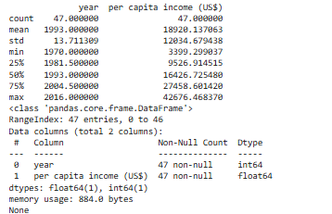

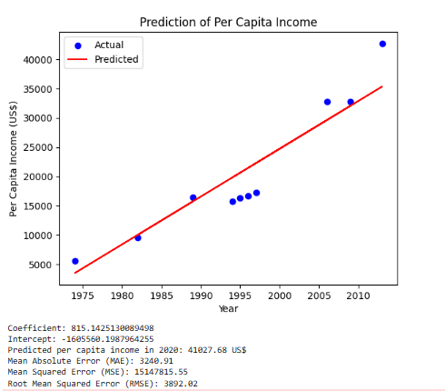

**Multiple Regression:**

import pandas as pd

import numpy as np

import matplotlib.pyplot as plt

from sklearn.model_selection import train_test_split

from sklearn.linear_model import LinearRegression

from sklearn.metrics import mean_absolute_error, mean_squared_error, r2_scor

# Load the dataset

data = pd.read_csv("hiring.csv")

# Function to convert experience from words to numbers

def convert_experience(value):

word_to_num = {"zero": 0, "one": 1, "two": 2, "three": 3, "four": 4, "five": 5, "six": 6,

"seven": 7, "eight": 8, "nine": 9, "ten": 10, "eleven": 11, "twelve": 12}

return word_to_num.get(value.lower(), value) if isinstance(value, str) else value

# Apply conversion

data['experience'] = data['experience'].apply(convert_experience)

# Handle missing values by removing rows with NaN

data = data.dropna()

# Convert all columns to numeric

data = data.astype(float)

# Analyze data distribution

print(data.describe())

print(data.info())

# Distribution plot visualization

plt.scatter(data['experience'], data['salary($)'], color='blue', label='Actual Data')

plt.xlabel("Experience (Years)")

plt.ylabel("Salary ($)")

plt.title("Experience vs Salary")

plt.legend()

plt.show()

# Relationship between variables

X = data[['experience', 'test_score(out of 10)', 'interview_score(out of 10)']]

y = data['salary($)']

# Split the data (80% training, 20% testing)

X_train, X_test, y_train, y_test = train_test_split(X, y, test_size=0.2, random_state=42)

# Train the model

model = LinearRegression()

model.fit(X_train, y_train)

# Predict the results

y_pred = model.predict(X_test)

# Visualize prediction

plt.scatter(y_test, y_pred, color='blue', label='Actual vs Predicted')

plt.xlabel("Actual Salary")

plt.ylabel("Predicted Salary")

plt.title("Salary Prediction")

plt.legend()

plt.show()

# Check values of coefficients and intercept

print(f"Coefficients: {model.coef_}")

print(f"Intercept: {model.intercept_}")

# Predict salary for given candidates

candidates = np.array([[2, 9, 6], [12, 10, 10]])

salary_predictions = model.predict(candidates)

print(f"Predicted salary for 2 yrs experience, 9 test score, 6 interview score: {salary_predictions[0]:.2f} US$")

print(f"Predicted salary for 12 yrs experience, 10 test score, 10 interview score: {salary_predictions[1]:.2f} US$")

# Calculate errors

mae = mean_absolute_error(y_test, y_pred)

mse = mean_squared_error(y_test, y_pred)

rmse = np.sqrt(mse)

print(f"Mean Absolute Error (MAE): {mae:.2f}")

print(f"Mean Squared Error (MSE): {mse:.2f}")

print(f"Root Mean Squared Error (RMSE): {rmse:.2f}")

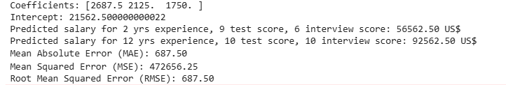

**Program 4**

**Build Logistic Regression Model for a given dataset**

**Screenshot:**

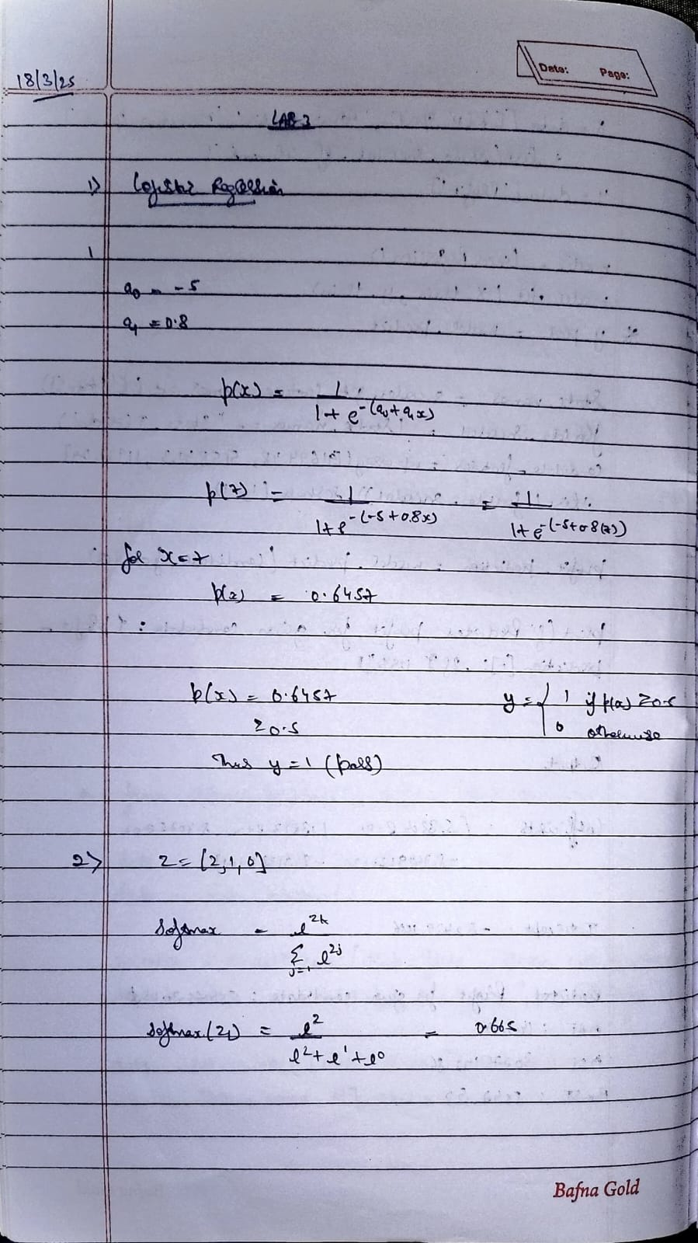

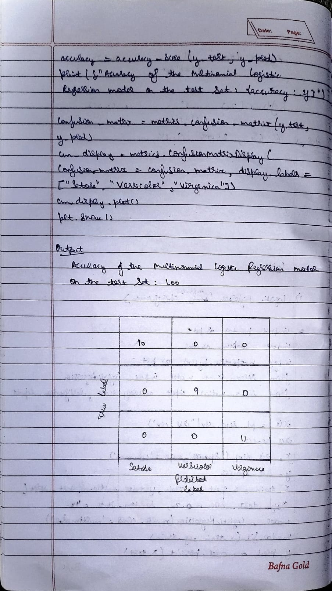

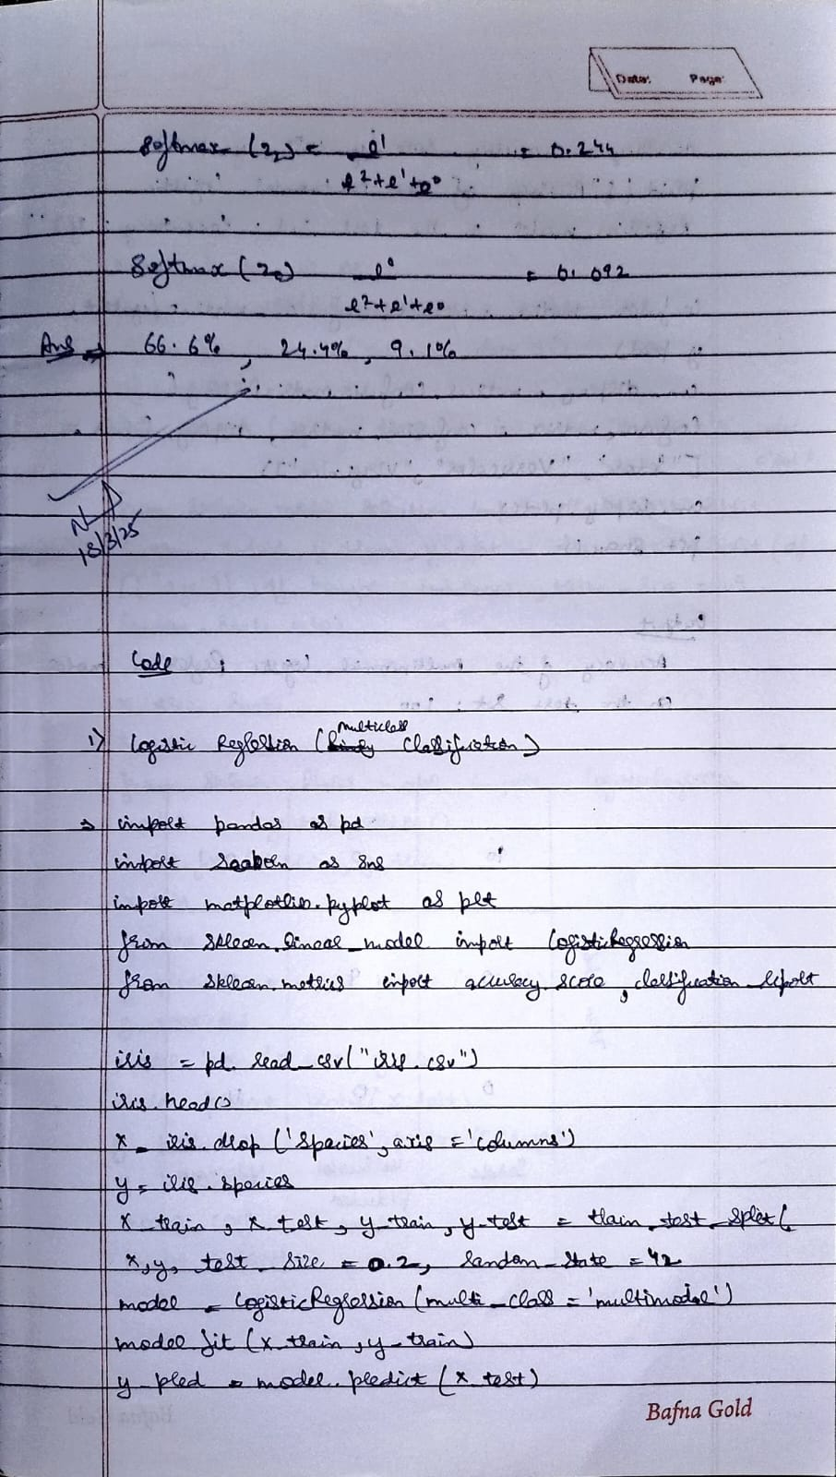

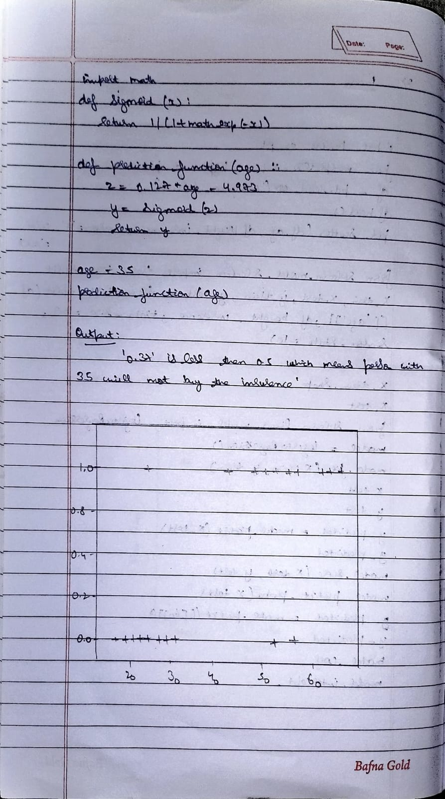

**Code:**

**Binary Logical Regression**

import pandas as pd

import seaborn as sns

import matplotlib.pyplot as plt

from sklearn.model_selection import train_test_split

from sklearn.linear_model import LogisticRegression

from sklearn.preprocessing import StandardScaler, OneHotEncoder

from sklearn.compose import ColumnTransformer

from sklearn.pipeline import Pipeline

from sklearn.metrics import accuracy_score, classification_report

# Load the dataset

file_path = 'HR_comma_sep.csv'

df = pd.read_csv(file_path)

# Display basic info

print(df.info())

print(df.head())

# Bar chart for Salary vs Retention

plt.figure(figsize=(8, 5))

sns.countplot(data=df, x='salary', hue='left')

plt.title('Impact of Salary on Employee Retention')

plt.xlabel('Salary Level')

plt.ylabel('Number of Employees')

plt.show()

# Bar chart for Department vs Retention

plt.figure(figsize=(12, 6))

sns.countplot(data=df, x='Department', hue='left', order=df['Department'].value_counts().index)

plt.title('Impact of Department on Employee Retention')

plt.xlabel('Department')

plt.ylabel('Number of Employees')

plt.xticks(rotation=45)

plt.show()

# Define features and target variable

X = df[['satisfaction_level', 'number_project', 'average_montly_hours', 'time_spend_company', 'salary', 'Department']]

y = df['left']

# Preprocessing: Scale numeric features and one-hot encode categorical features

preprocessor = ColumnTransformer(transformers=[

('num', StandardScaler(), ['satisfaction_level', 'number_project', 'average_montly_hours', 'time_spend_company']),

('cat', OneHotEncoder(), ['salary', 'Department'])

])

# Create pipeline with logistic regression

model = Pipeline(steps=[

('preprocessor', preprocessor),

('classifier', LogisticRegression(max_iter=1000))

])

# Split data into training and test sets

X_train, X_test, y_train, y_test = train_test_split(X, y, test_size=0.2, random_state=42)

# Train the model

model.fit(X_train, y_train)

# Predict on test data

y_pred = model.predict(X_test)

# Measure accuracy and display classification report

accuracy = accuracy_score(y_test, y_pred)

report = classification_report(y_test, y_pred)

print(f'Accuracy: {accuracy:.2%}')

print('Classification Report:')

print(report)

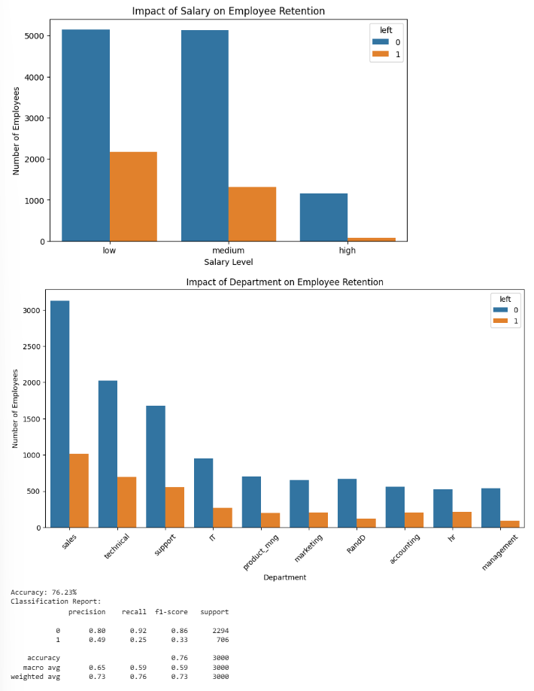

**Multi Logical classification**

import pandas as pd

import seaborn as sns

import matplotlib.pyplot as plt

from sklearn.model_selection import train_test_split

from sklearn.linear_model import LogisticRegression

from sklearn.metrics import accuracy_score, classification_report, confusion_matrix, ConfusionMatrixDisplay

# Load the datasets

zoo_data = pd.read_csv('zoo-data.csv')

zoo_class_type = pd.read_csv('zoo-class-type.csv')

# Display basic info

print(zoo_data.info())

print(zoo_data.head())

print(zoo_class_type.info())

print(zoo_class_type.head())

# Drop the animal_name column since it's not useful for prediction

zoo_data_cleaned = zoo_data.drop('animal_name', axis=1)

# Define features and target variable

X = zoo_data_cleaned.drop('class_type', axis=1)

y = zoo_data_cleaned['class_type']

# Split data into training and test sets

X_train, X_test, y_train, y_test = train_test_split(

X, y, test_size=0.2, random_state=42)

# Train logistic regression model using softmax for multi-class classification

model = LogisticRegression(max_iter=1000, multi_class='multinomial', solver='lbfgs')

model.fit(X_train, y_train)

# Predict on test data

y_pred = model.predict(X_test)

# Measure accuracy and generate classification report

accuracy = accuracy_score(y_test, y_pred)

report = classification_report(y_test, y_pred)

print(f'Accuracy: {accuracy:.2%}')

print('Classification Report:')

print(report)

# Plot confusion matrix

cm = confusion_matrix(y_test, y_pred, labels=sorted(y.unique()))

disp = ConfusionMatrixDisplay(confusion_matrix=cm, display_labels=sorted(y.unique()))

disp.plot(cmap='Blues')

plt.title('Confusion Matrix')

plt.show()

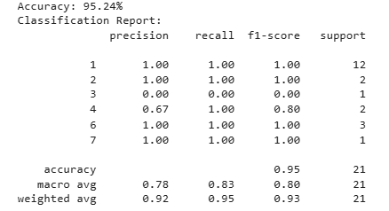

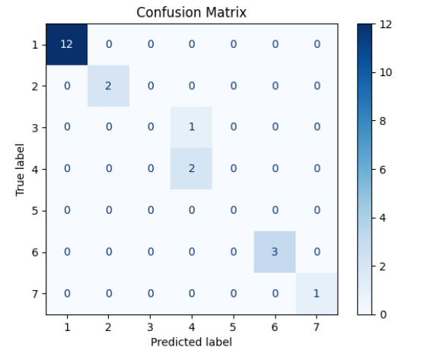

**Program 5**

**Use an appropriate data set for building the decision tree (ID3) and apply this knowledge to classify a new sample.**

**Screenshot:**

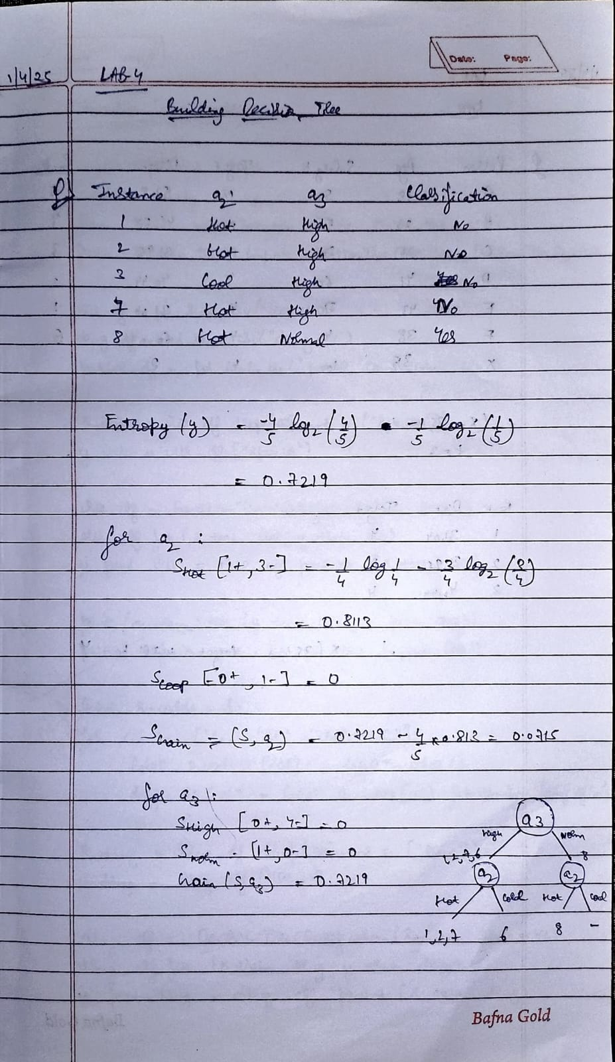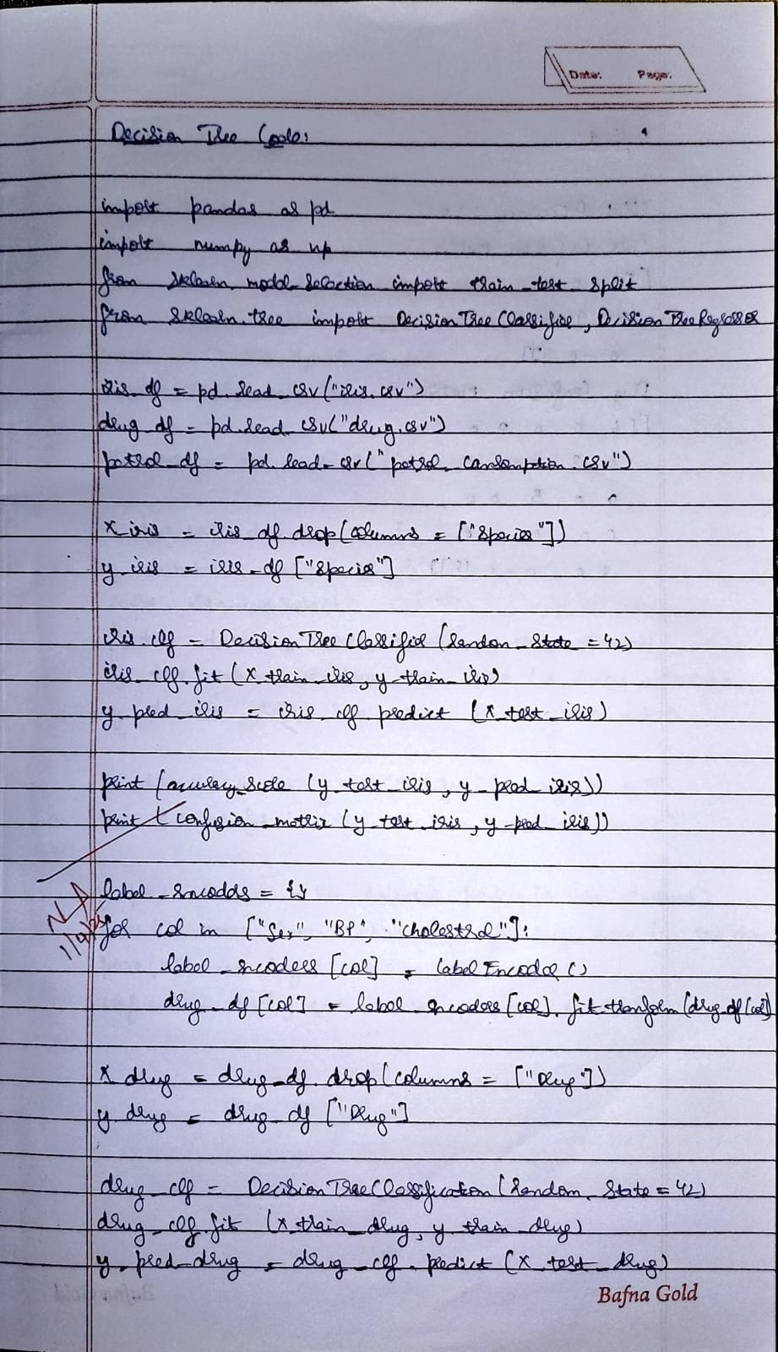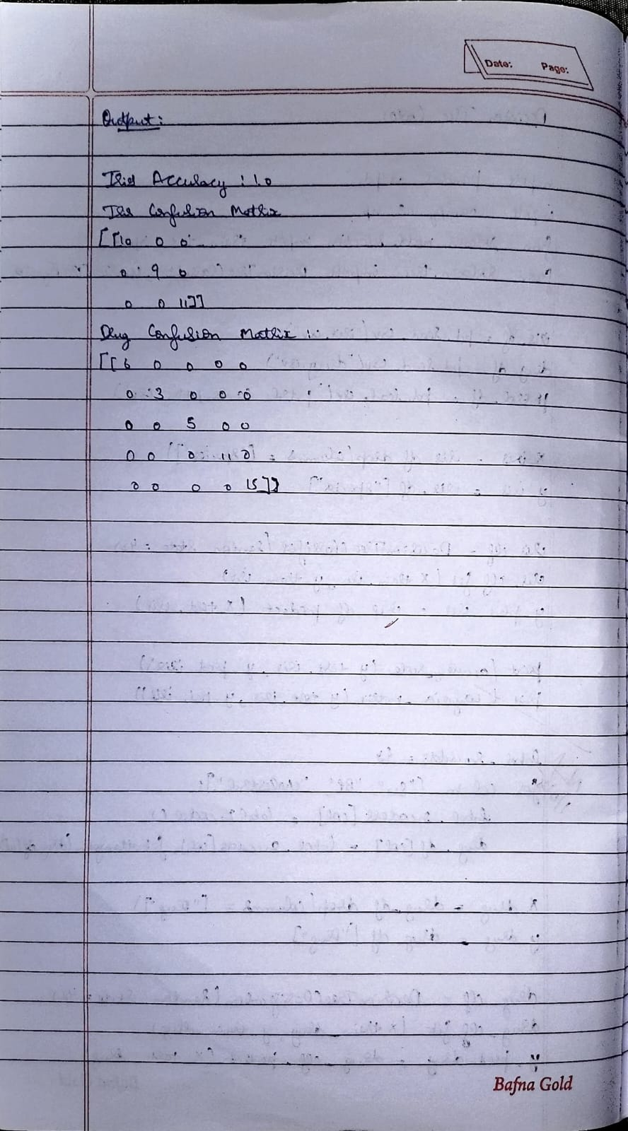\\\

**Code:**

import pandas as pd

from sklearn.model_selection import train_test_split

from sklearn.tree import DecisionTreeClassifier, DecisionTreeRegressor

from sklearn.metrics import accuracy_score, confusion_matrix, mean_absolute_error, mean_squared_error

import numpy as np

from sklearn.preprocessing import LabelEncoder

# Load datasets

iris_df = pd.read_csv("iris.csv")

drug_df = pd.read_csv("drug.csv")

petrol_df = pd.read_csv("petrol_consumption.csv")

# Prepare IRIS dataset

X_iris = iris_df.drop(columns=["species"])

y_iris = iris_df["species"]

X_train_iris, X_test_iris, y_train_iris, y_test_iris = train_test_split(X_iris, y_iris, test_size=0.2, random_state=42)

# Train Decision Tree Classifier for IRIS

iris_clf = DecisionTreeClassifier(random_state=42)

iris_clf.fit(X_train_iris, y_train_iris)

y_pred_iris = iris_clf.predict(X_test_iris)

# IRIS Metrics

print("Iris Accuracy:", accuracy_score(y_test_iris, y_pred_iris))

print("Iris Confusion Matrix:\n", confusion_matrix(y_test_iris, y_pred_iris))

# Prepare Drug dataset (encode categorical variables)

label_encoders = {}

for col in ["Sex", "BP", "Cholesterol"]:

label_encoders[col] = LabelEncoder()

drug_df[col] = label_encoders[col].fit_transform(drug_df[col])

X_drug = drug_df.drop(columns=["Drug"])

y_drug = drug_df["Drug"]

X_train_drug, X_test_drug, y_train_drug, y_test_drug = train_test_split(X_drug, y_drug, test_size=0.2, random_state=42)

# Train Decision Tree Classifier for Drug dataset

drug_clf = DecisionTreeClassifier(random_state=42)

drug_clf.fit(X_train_drug, y_train_drug)

y_pred_drug = drug_clf.predict(X_test_drug)

# Drug Metrics

print("Drug Accuracy:", accuracy_score(y_test_drug, y_pred_drug))

print("Drug Confusion Matrix:\n", confusion_matrix(y_test_drug, y_pred_drug))

# Prepare Petrol Consumption dataset

X_petrol = petrol_df.drop(columns=["Petrol_Consumption"])

y_petrol = petrol_df["Petrol_Consumption"]

X_train_petrol, X_test_petrol, y_train_petrol, y_test_petrol = train_test_split(X_petrol, y_petrol, test_size=0.2, random_state=42)

# Train Decision Tree Regressor for Petrol dataset

petrol_reg = DecisionTreeRegressor(random_state=42)

petrol_reg.fit(X_train_petrol, y_train_petrol)

y_pred_petrol = petrol_reg.predict(X_test_petrol)

# Petrol Regression Metrics

print("Mean Absolute Error (MAE):", mean_absolute_error(y_test_petrol, y_pred_petrol))

print("Mean Squared Error (MSE):", mean_squared_error(y_test_petrol, y_pred_petrol))

print("Root Mean Squared Error (RMSE):", np.sqrt(mean_squared_error(y_test_petrol, y_pred_petrol)))

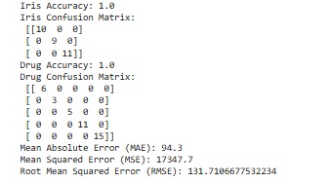

**Program 6**

**Build KNN Classification model for a given dataset.**

**Screenshot :**

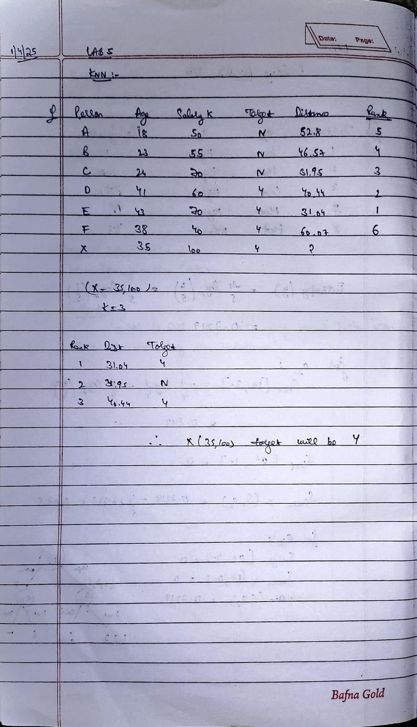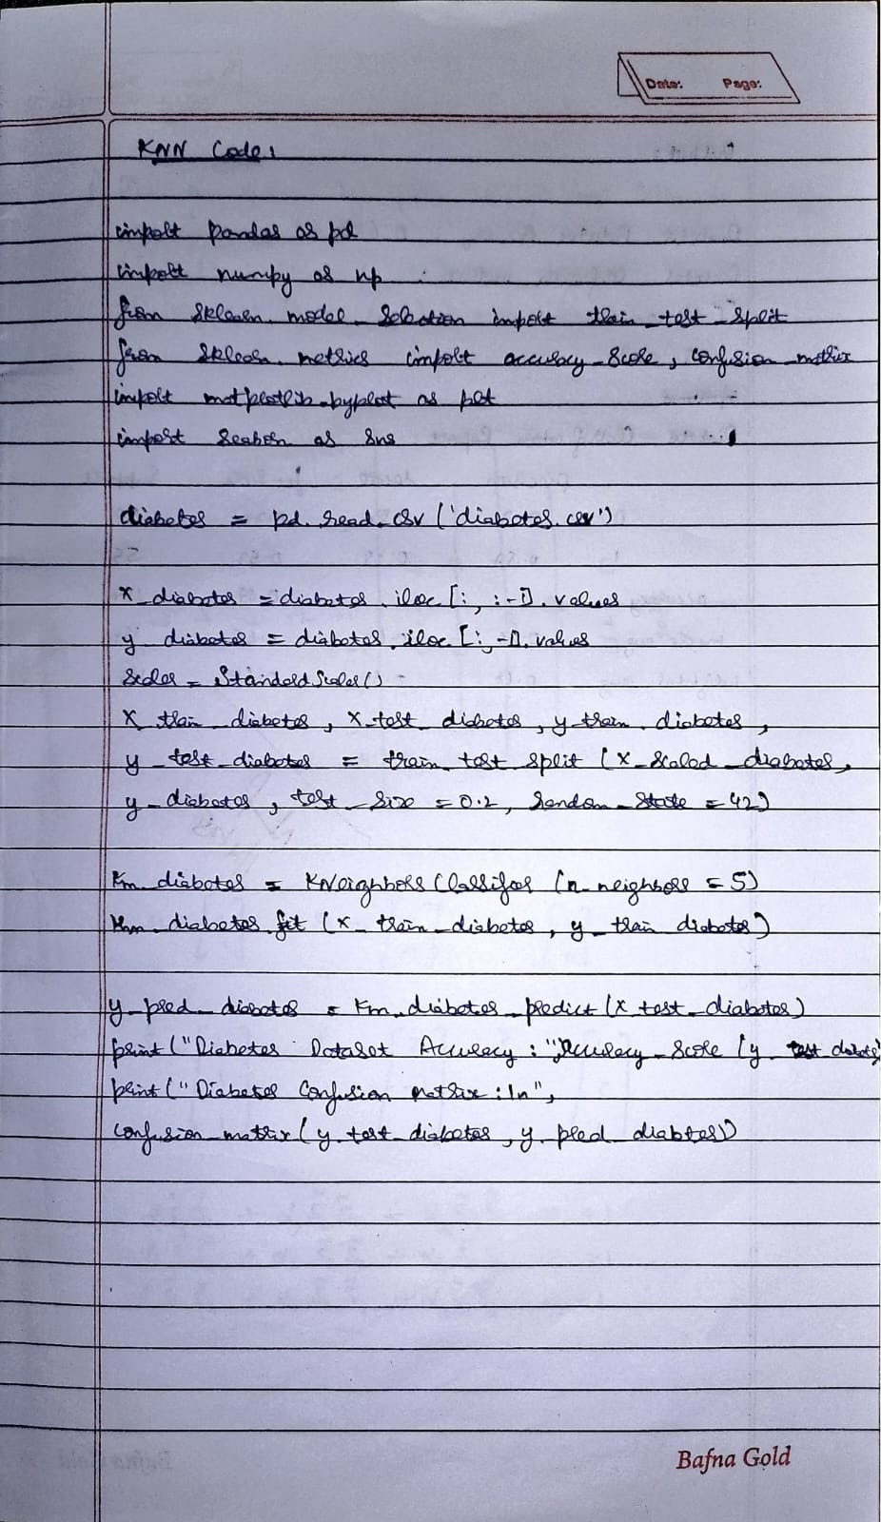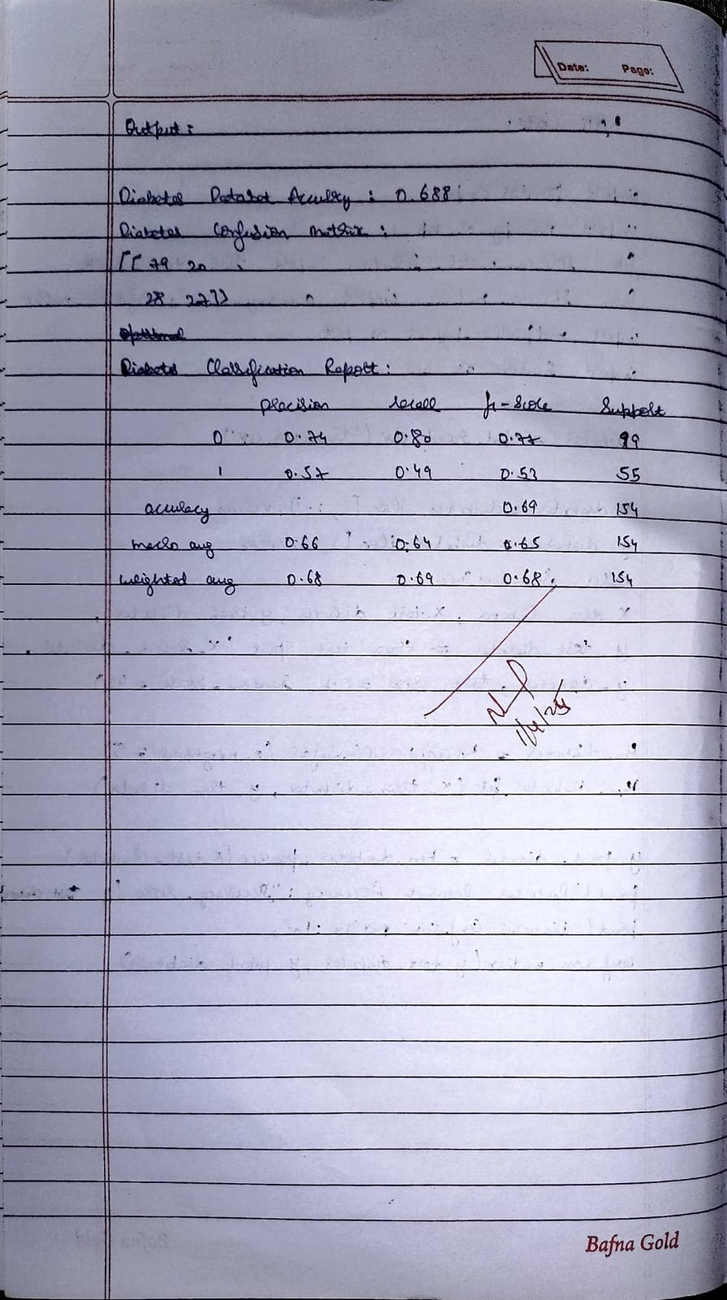

**Code:**

import pandas as pd

import numpy as np

from sklearn.model_selection import train_test_split

from sklearn.preprocessing import StandardScaler

from sklearn.neighbors import KNeighborsClassifier

from sklearn.metrics import accuracy_score, confusion_matrix, classification_report

import matplotlib.pyplot as plt

import seaborn as sns

iris = pd.read_csv('iris.csv')

X_iris = iris.iloc[:, :-1].values

y_iris = iris.iloc[:, -1].values

X_train_iris, X_test_iris, y_train_iris, y_test_iris = train_test_split(X_iris, y_iris, test_size=0.2, random_state=42)

knn_iris = KNeighborsClassifier(n_neighbors=3)

knn_iris.fit(X_train_iris, y_train_iris)

y_pred_iris = knn_iris.predict(X_test_iris)

print("IRIS Dataset Accuracy:", accuracy_score(y_test_iris, y_pred_iris))

print("IRIS Confusion Matrix:\n", confusion_matrix(y_test_iris, y_pred_iris))

print("IRIS Classification Report:\n", classification_report(y_test_iris, y_pred_iris))

diabetes = pd.read_csv('diabetes.csv')

X_diabetes = diabetes.iloc[:, :-1].values

y_diabetes = diabetes.iloc[:, -1].values

scaler = StandardScaler()

X_scaled_diabetes = scaler.fit_transform(X_diabetes)

X_train_diabetes, X_test_diabetes, y_train_diabetes, y_test_diabetes = train_test_split(X_scaled_diabetes, y_diabetes, test_size=0.2, random_state=42)

knn_diabetes = KNeighborsClassifier(n_neighbors=5)

knn_diabetes.fit(X_train_diabetes, y_train_diabetes)

y_pred_diabetes = knn_diabetes.predict(X_test_diabetes)

print("Diabetes Dataset Accuracy:", accuracy_score(y_test_diabetes, y_pred_diabetes))

print("Diabetes Confusion Matrix:\n", confusion_matrix(y_test_diabetes, y_pred_diabetes))

print("Diabetes Classification Report:\n", classification_report(y_test_diabetes, y_pred_diabetes))

X_heart = heart.iloc[:, :-1].values

y_heart = heart.iloc[:, -1].values

X_train_heart, X_test_heart, y_train_heart, y_test_heart = train_test_split(X_heart, y_heart, test_size=0.2, random_state=42)

accuracy_scores = []

for k in range(1, 21):

knn_heart = KNeighborsClassifier(n_neighbors=k)

knn_heart.fit(X_train_heart, y_train_heart)

y_pred_heart = knn_heart.predict(X_test_heart)

accuracy_scores.append(accuracy_score(y_test_heart, y_pred_heart))

optimal_k = accuracy_scores.index(max(accuracy_scores)) + 1

print("Optimal K for Heart Dataset:", optimal_k)

knn_heart = KNeighborsClassifier(n_neighbors=optimal_k)

knn_heart.fit(X_train_heart, y_train_heart)

y_pred_heart = knn_heart.predict(X_test_heart)

print("Heart Dataset Accuracy:", accuracy_score(y_test_heart, y_pred_heart))

print("Heart Confusion Matrix:\n", confusion_matrix(y_test_heart, y_pred_heart))

print("Heart Classification Report:\n", classification_report(y_test_heart, y_pred_heart))

plt.figure(figsize=(8, 6))

sns.heatmap(confusion_matrix(y_test_heart, y_pred_heart), annot=True, fmt="d", cmap="Blues")

plt.title("Heart Dataset Confusion Matrix")

plt.xlabel("Predicted")

plt.ylabel("Actual")

plt.show()

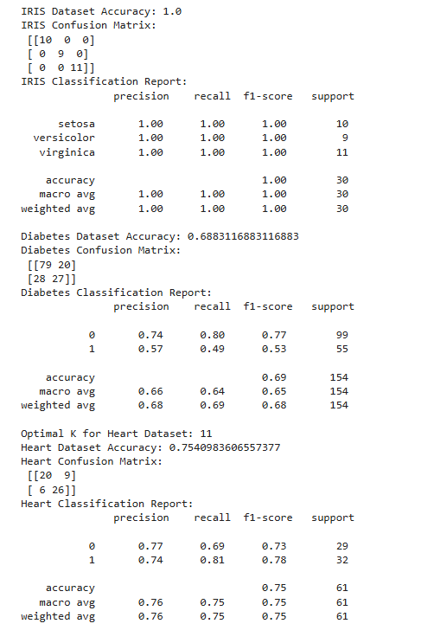

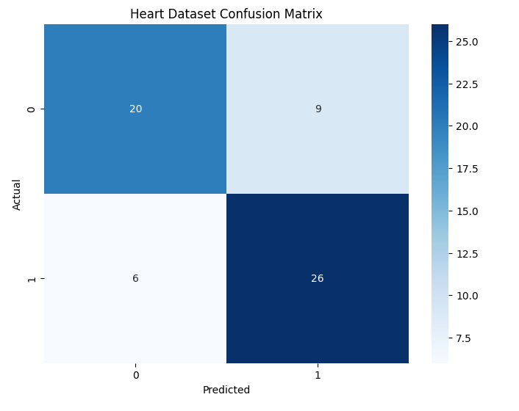

**Program7**

**Build Support vector machine model for a given dataset**

**Screenshot:**

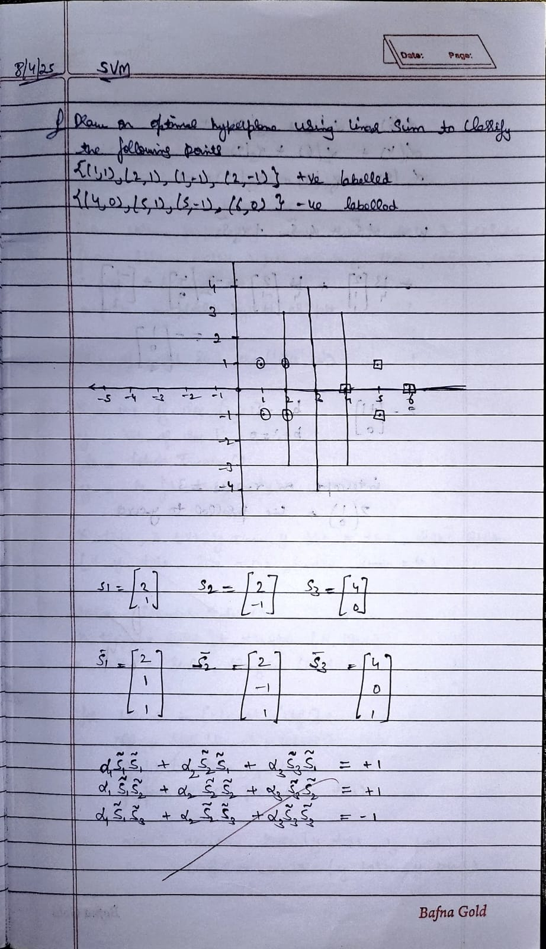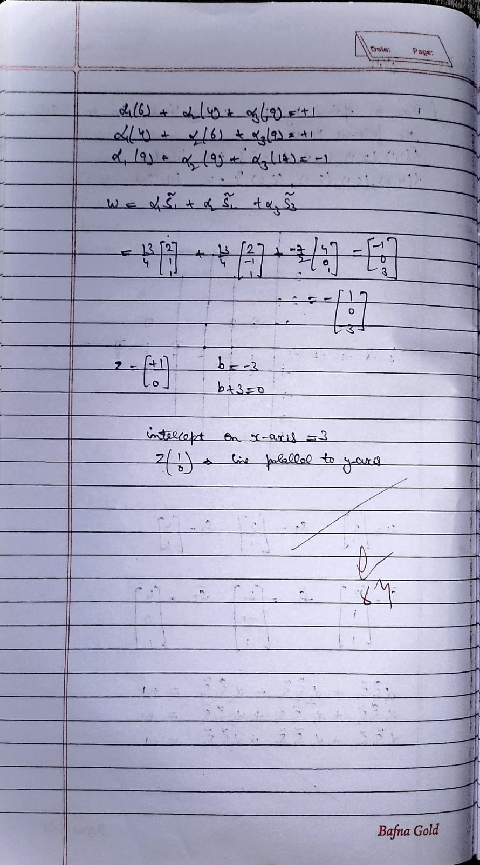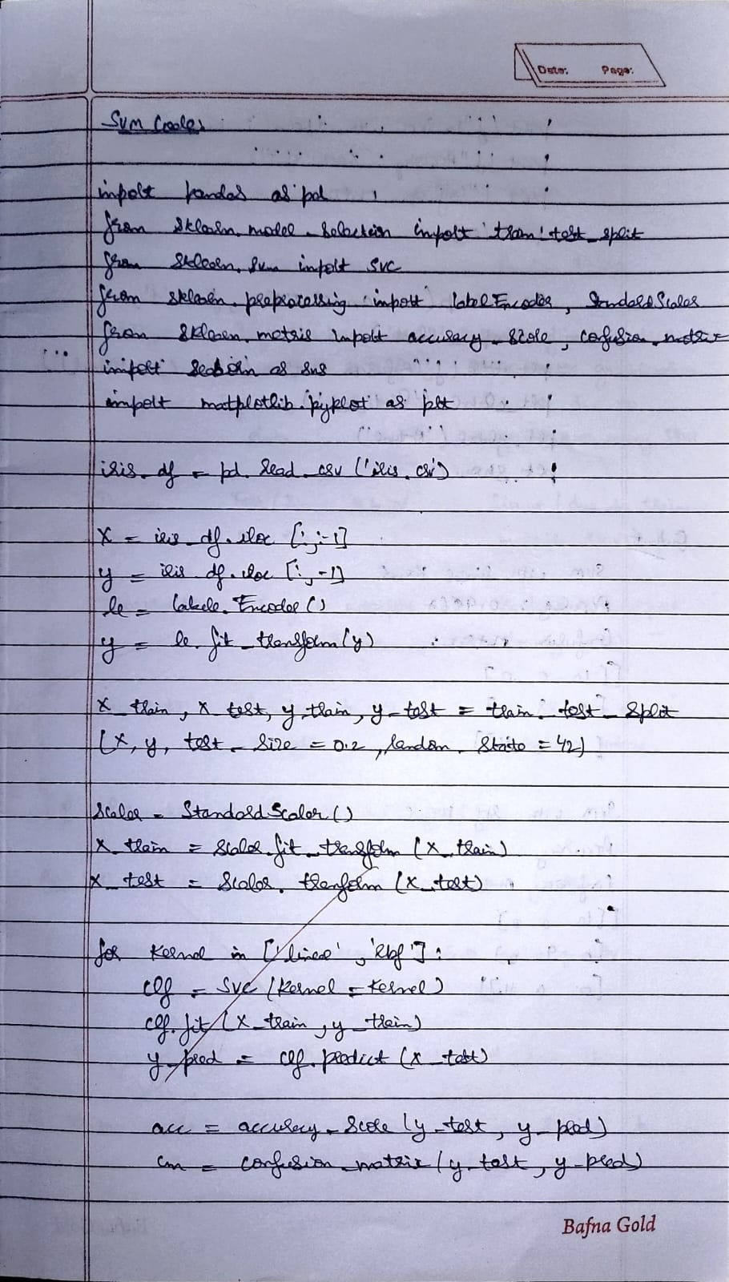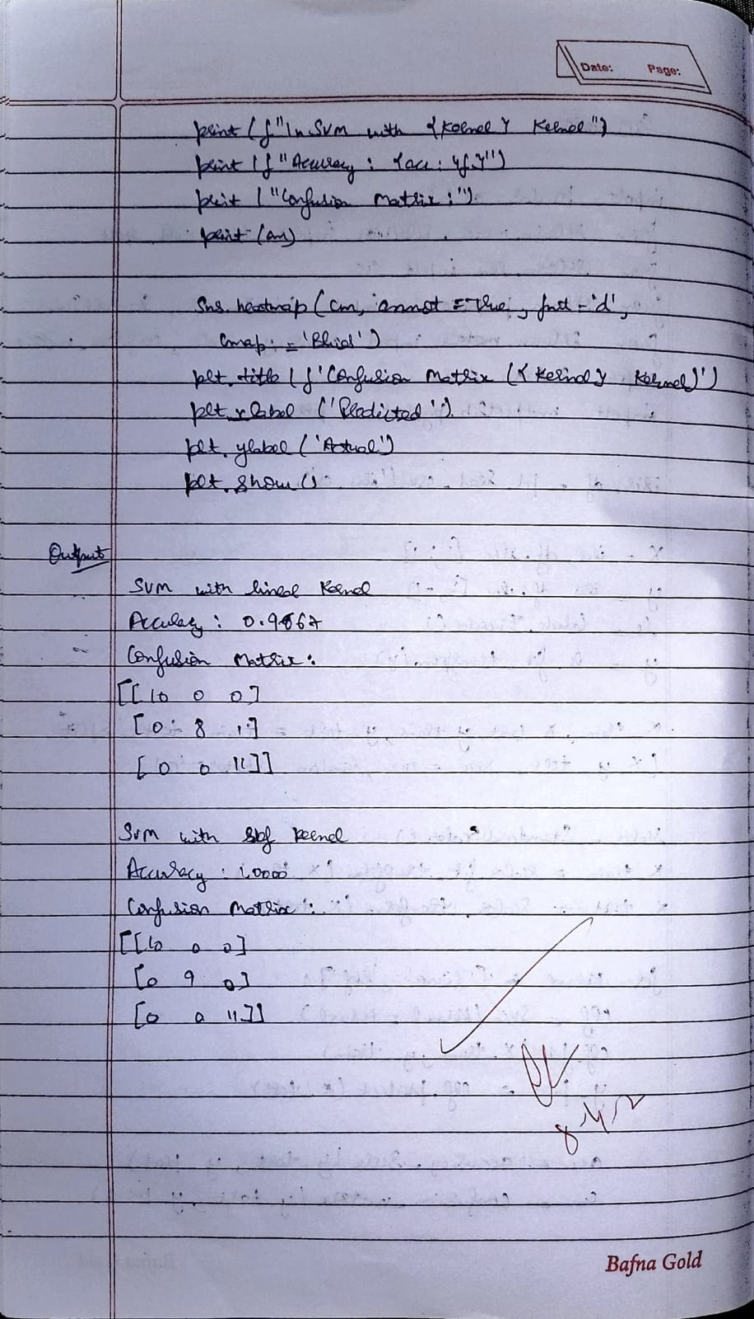

**Code:**

**Iris.csv**

import pandas as pd

from sklearn.model_selection import train_test_split

from sklearn.svm import SVC

from sklearn.preprocessing import LabelEncoder, StandardScaler

from sklearn.metrics import accuracy_score, confusion_matrix

import seaborn as sns

import matplotlib.pyplot as plt

# Load the IRIS dataset

iris_df = pd.read_csv('iris.csv')

# Encode labels if necessary

X = iris_df.iloc[:, :-1]

y = iris_df.iloc[:, -1]

le = LabelEncoder()

y = le.fit_transform(y)

# Split the data

X_train, X_test, y_train, y_test = train_test_split(X, y, test_size=0.2, random_state=42)

# Standardize features

scaler = StandardScaler()

X_train = scaler.fit_transform(X_train)

X_test = scaler.transform(X_test)

# Train and evaluate both linear and RBF kernels

for kernel in ['linear', 'rbf']:

clf = SVC(kernel=kernel)

clf.fit(X_train, y_train)

y_pred = clf.predict(X_test)

acc = accuracy_score(y_test, y_pred)

cm = confusion_matrix(y_test, y_pred)

print(f"\nSVM with {kernel} kernel")

print(f"Accuracy: {acc:.4f}")

print("Confusion Matrix:")

print(cm)

# Plot confusion matrix

sns.heatmap(cm, annot=True, fmt='d', cmap='Blues')

plt.title(f'Confusion Matrix ({kernel} kernel)')

plt.xlabel('Predicted')

plt.ylabel('Actual')

plt.show()

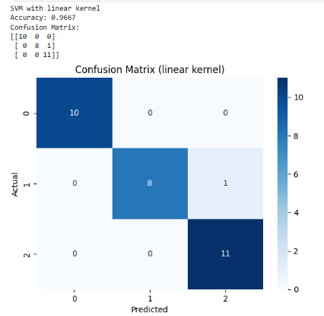

**Letter Recognition**

from sklearn.preprocessing import label_binarize

from sklearn.metrics import roc_curve, auc

# Load the Letter Recognition dataset

letter_df = pd.read_csv('letter-recognition.csv')

X = letter_df.iloc[:, 1:]

y = letter_df.iloc[:, 0]

# Encode labels

le = LabelEncoder()

y_enc = le.fit_transform(y)

# Binarize for ROC

y_bin = label_binarize(y_enc, classes=range(len(le.classes_)))

# Split data

X_train, X_test, y_train, y_test = train_test_split(X, y_enc, test_size=0.2, random_state=42)

# Scale features

scaler = StandardScaler()

X_train = scaler.fit_transform(X_train)

X_test = scaler.transform(X_test)

# Train SVM

clf = SVC(kernel='linear', probability=True)

clf.fit(X_train, y_train)

y_pred = clf.predict(X_test)

y_score = clf.predict_proba(X_test)

# Accuracy & confusion matrix

acc = accuracy_score(y_test, y_pred)

cm = confusion_matrix(y_test, y_pred)

print(f"\nLetter Recognition - SVM (RBF Kernel)")

print(f"Accuracy: {acc:.4f}")

print("Confusion Matrix:")

print(cm)

# Plot confusion matrix

sns.heatmap(cm, cmap='Blues')

plt.title('Confusion Matrix')

plt.xlabel('Predicted')

plt.ylabel('Actual')

plt.show()

# ROC & AUC for first few classes

y_test_bin = label_binarize(y_test, classes=range(len(le.classes_)))

fpr = dict()

tpr = dict()

roc_auc = dict()

n_classes = y_test_bin.shape[1]

for i in range(n_classes):

fpr[i], tpr[i], _ = roc_curve(y_test_bin[:, i], y_score[:, i])

roc_auc[i] = auc(fpr[i], tpr[i])

# Plot ROC curves for first 5 classes

plt.figure(figsize=(10, 6))

for i in range(5): # limit to first 5 for clarity

plt.plot(fpr[i], tpr[i], label=f'Class {le.classes_[i]} (AUC = {roc_auc[i]:.2f})')

plt.plot([0, 1], [0, 1], 'k--')

plt.title('ROC Curve (First 5 Classes)')

plt.xlabel('False Positive Rate')

plt.ylabel('True Positive Rate')

plt.legend()

plt.grid(True)

plt.show()

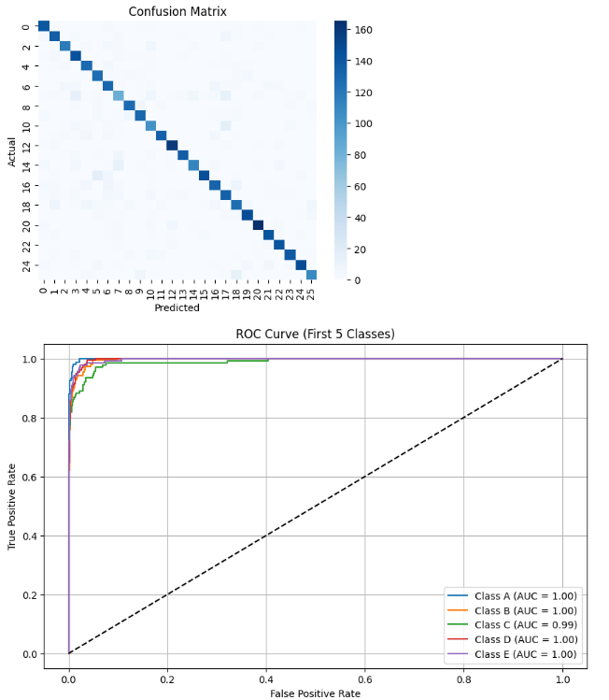

**Horse Mule dataset**

import pandas as pd

import numpy as np

import matplotlib.pyplot as plt

from sklearn import svm

from sklearn.metrics import accuracy_score

# Step 1: Create dataset

data = {

"Height": [44.0, 52.1, 57.1, 33.0, 27.8, 27.2, 32.0, 45.1, 56.7, 56.9, 122.1],

"Weight": [126.3, 136.9, 109.2, 148.3, 110.4, 107.8, 128.4, 120.2, 140.2, 139.2, 154.1],

"Label": ["Horse", "Horse", "Horse", "Mule", "Mule", "Mule", "Mule", "Horse", "Horse", "Horse", "Mule"]

}

df = pd.DataFrame(data)

# Step 2: Save CSV

df.to_csv("horses_mules_dataset.csv", index=False)

# Step 3: Load dataset

df = pd.read_csv("horses_mules_dataset.csv")

# Step 4: Preprocess data

X = df[["Height", "Weight"]].values

y = df["Label"].map({"Horse": 0, "Mule": 1}).values # Convert to numeric

# Step 5: Train SVM model

model = svm.SVC(kernel='linear')

model.fit(X, y)

# Step 6: Plot data and support vectors

plt.figure(figsize=(8,6))

plt.scatter(X[:, 0], X[:, 1], c=y, cmap='bwr', s=70, edgecolors='k')

plt.xlabel("Height")

plt.ylabel("Weight")

plt.title("SVM Classification: Horse vs Mule")

# Plot support vectors

plt.scatter(model.support_vectors_[:, 0], model.support_vectors_[:, 1],

s=150, facecolors='none', edgecolors='k', label='Support Vectors')

plt.legend()

plt.grid(True)

plt.show()

# Step 7: Accuracy

y_pred = model.predict(X)

acc = accuracy_score(y, y_pred)

print("Accuracy:", acc)

# Step 8: Support Vectors

print("Support Vectors:\n", model.support_vectors_)

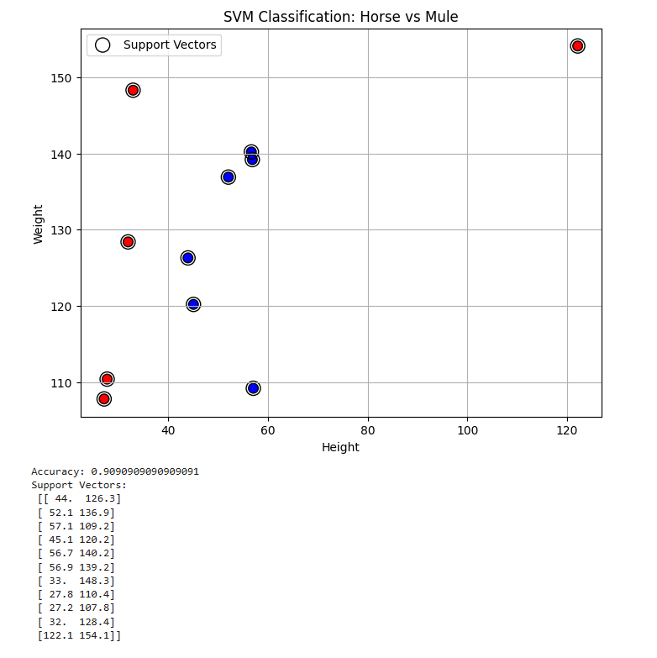

**Program 8**

**Implement Random forest ensemble method on a given dataset**

**Screenshot:**

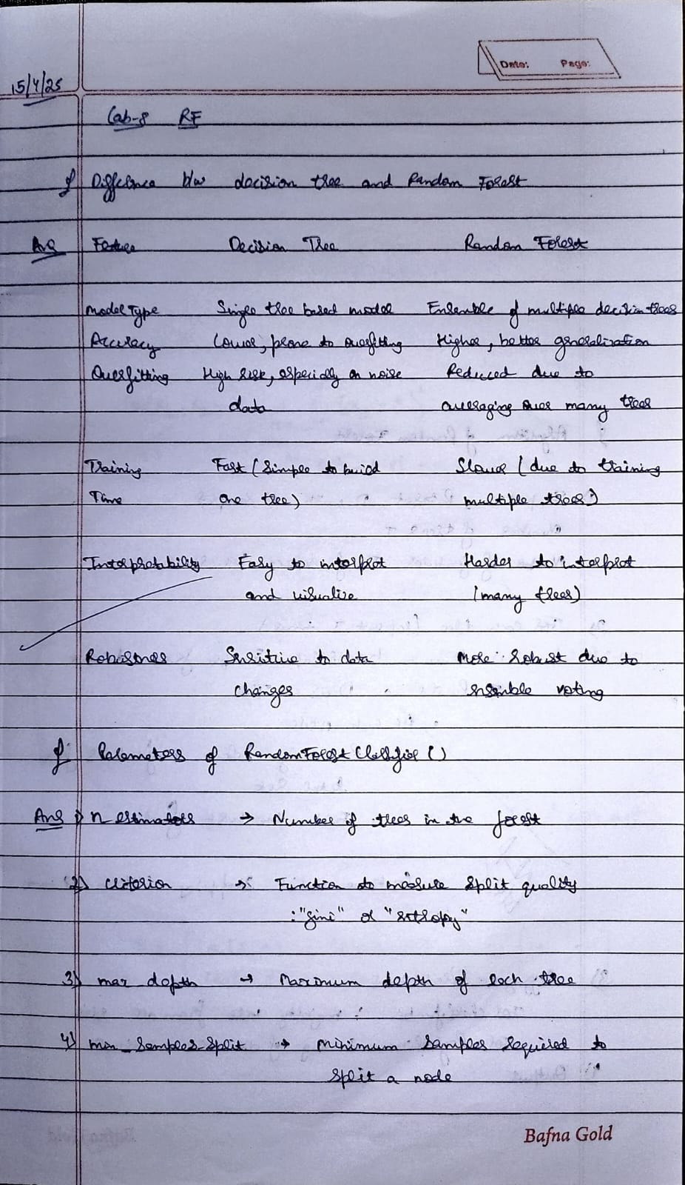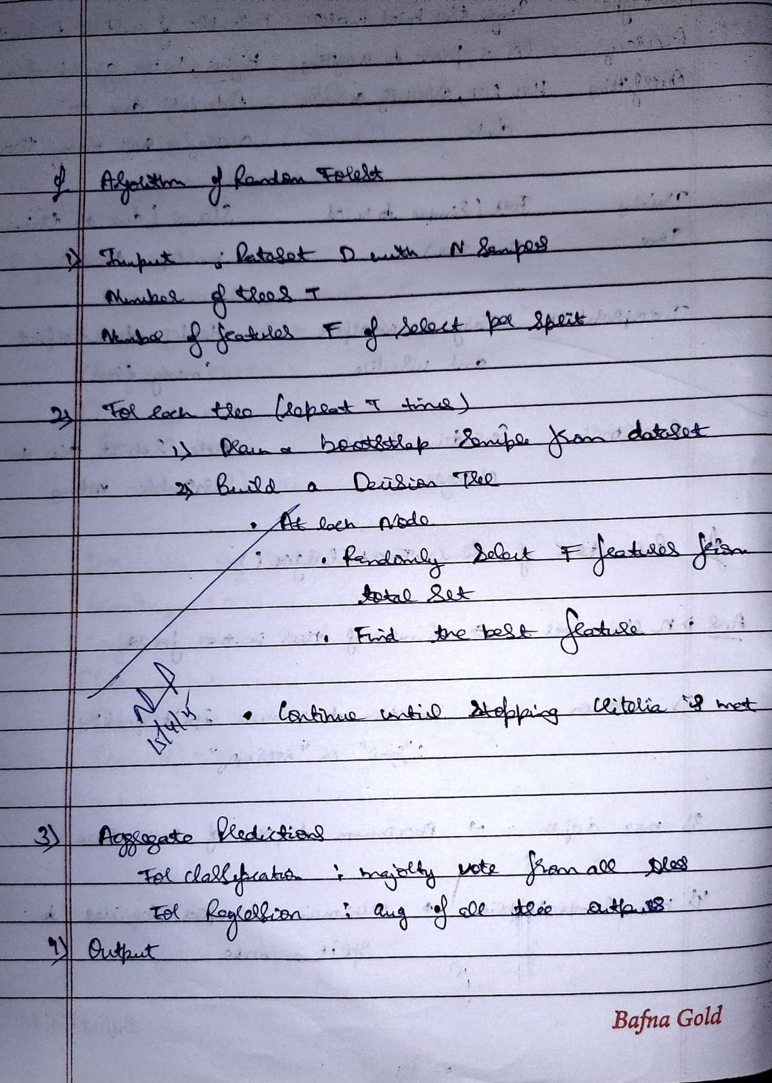

**Code:**

**Iris.csv**

import pandas as pd

from sklearn.model_selection import train_test_split

from sklearn.ensemble import RandomForestClassifier

from sklearn.metrics import accuracy_score

iris_df = pd.read_csv('iris.csv')

# Features and target

X = iris_df.iloc[:, :-1]

y = iris_df.iloc[:, -1]

X_train, X_test, y_train, y_test = train_test_split(X, y, test_size=0.2, random_state=42)

# Train model with default n_estimators = 10

model_default = RandomForestClassifier(n_estimators=10, random_state=42)

model_default.fit(X_train, y_train)

y_pred_default = model_default.predict(X_test)

default_score = accuracy_score(y_test, y_pred_default)

print(f"Default score with n_estimators=10: {default_score:.4f}")

# Fine-tune n_estimators

best_score = 0

best_n = 10

for n in range(5, 105, 5):

model = RandomForestClassifier(n_estimators=n, random_state=42)

model.fit(X_train, y_train)

y_pred = model.predict(X_test)

score = accuracy_score(y_test, y_pred)

print(f"n_estimators={n}, Accuracy={score:.4f}")

if score > best_score:

best_score = score

best_n = n

print(f"\nBest score: {best_score:.4f} with n_estimators={best_n}")

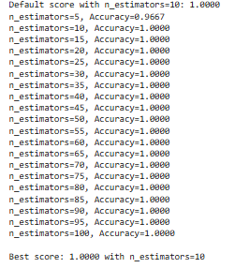

**Train.csv**

import pandas as pd

from sklearn.model_selection import train_test_split

from sklearn.ensemble import RandomForestClassifier

from sklearn.preprocessing import LabelEncoder

from sklearn.impute import SimpleImputer

from sklearn.metrics import accuracy_score, confusion_matrix

# Load dataset

df = pd.read_csv('train.csv')

# Separate features and target

X_raw = df.iloc[:, :-1]

y_raw = df.iloc[:, -1]

# Encode categorical features using one-hot encoding

X_encoded = pd.get_dummies(X_raw)

# Encode target if it's categorical

if y_raw.dtype == 'object':

y_encoded = LabelEncoder().fit_transform(y_raw)

else:

y_encoded = y_raw

# Handle missing values using imputation

imputer = SimpleImputer(strategy='most_frequent')

X_imputed = pd.DataFrame(imputer.fit_transform(X_encoded), columns=X_encoded.columns)

# Split dataset (80% train, 20% test)

X_train, X_test, y_train, y_test = train_test_split(X_imputed, y_encoded, test_size=0.2, random_state=42)

# Train Random Forest classifier

model = RandomForestClassifier(random_state=42)

model.fit(X_train, y_train)

# Predict and evaluate

y_pred = model.predict(X_test)

accuracy = accuracy_score(y_test, y_pred)

conf_matrix = confusion_matrix(y_test, y_pred)

# Output results

print("Accuracy Score:", accuracy)

print("Confusion Matrix:\n", conf_matrix)

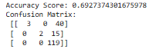

**Program 9**

**Implement Boosting ensemble method on a given dataset**

**Screenshot:**

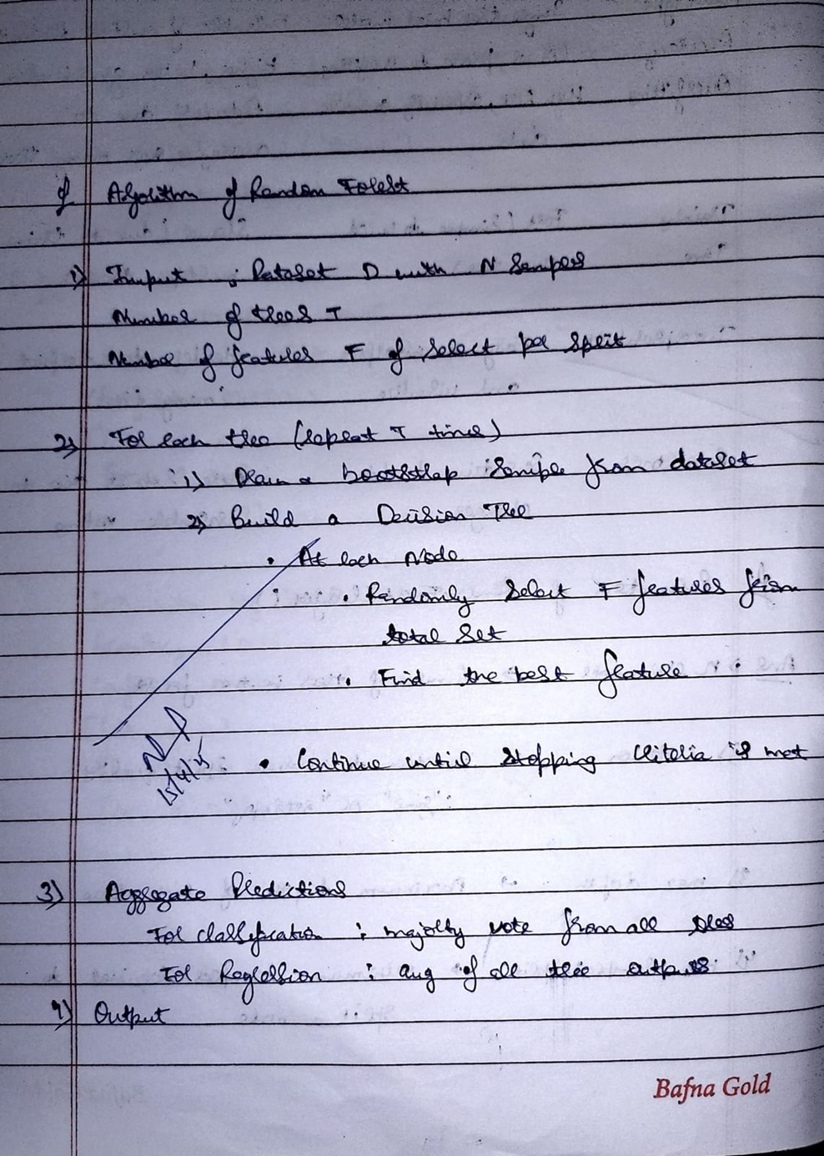

**Code:**

**Income.csv**

import pandas as pd

from sklearn.model_selection import train_test_split

from sklearn.ensemble import AdaBoostClassifier

from sklearn.preprocessing import LabelEncoder

from sklearn.impute import SimpleImputer

from sklearn.metrics import accuracy_score, confusion_matrix

# Load dataset

df = pd.read_csv('income.csv')

# Separate features and target

X_raw = df.iloc[:, :-1]

y_raw = df.iloc[:, -1]

# One-hot encode categorical features

X_encoded = pd.get_dummies(X_raw)

# Encode target if it's categorical

if y_raw.dtype == 'object':

y_encoded = LabelEncoder().fit_transform(y_raw)

else:

y_encoded = y_raw

# Handle missing values using most frequent strategy

imputer = SimpleImputer(strategy='most_frequent')

X_imputed = pd.DataFrame(imputer.fit_transform(X_encoded), columns=X_encoded.columns)

X_train, X_test, y_train, y_test = train_test_split(X_imputed, y_encoded, test_size=0.2, random_state=42)

model = AdaBoostClassifier(random_state=42)

model.fit(X_train, y_train)

y_pred = model.predict(X_test)

accuracy = accuracy_score(y_test, y_pred)

conf_matrix = confusion_matrix(y_test, y_pred)

print("Accuracy Score:", accuracy)

print("Confusion Matrix:\n", conf_matrix)

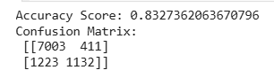

**Program 10**

**Build k-Means algorithm to cluster a set of data stored in a .CSV file**

**Screenshot:**

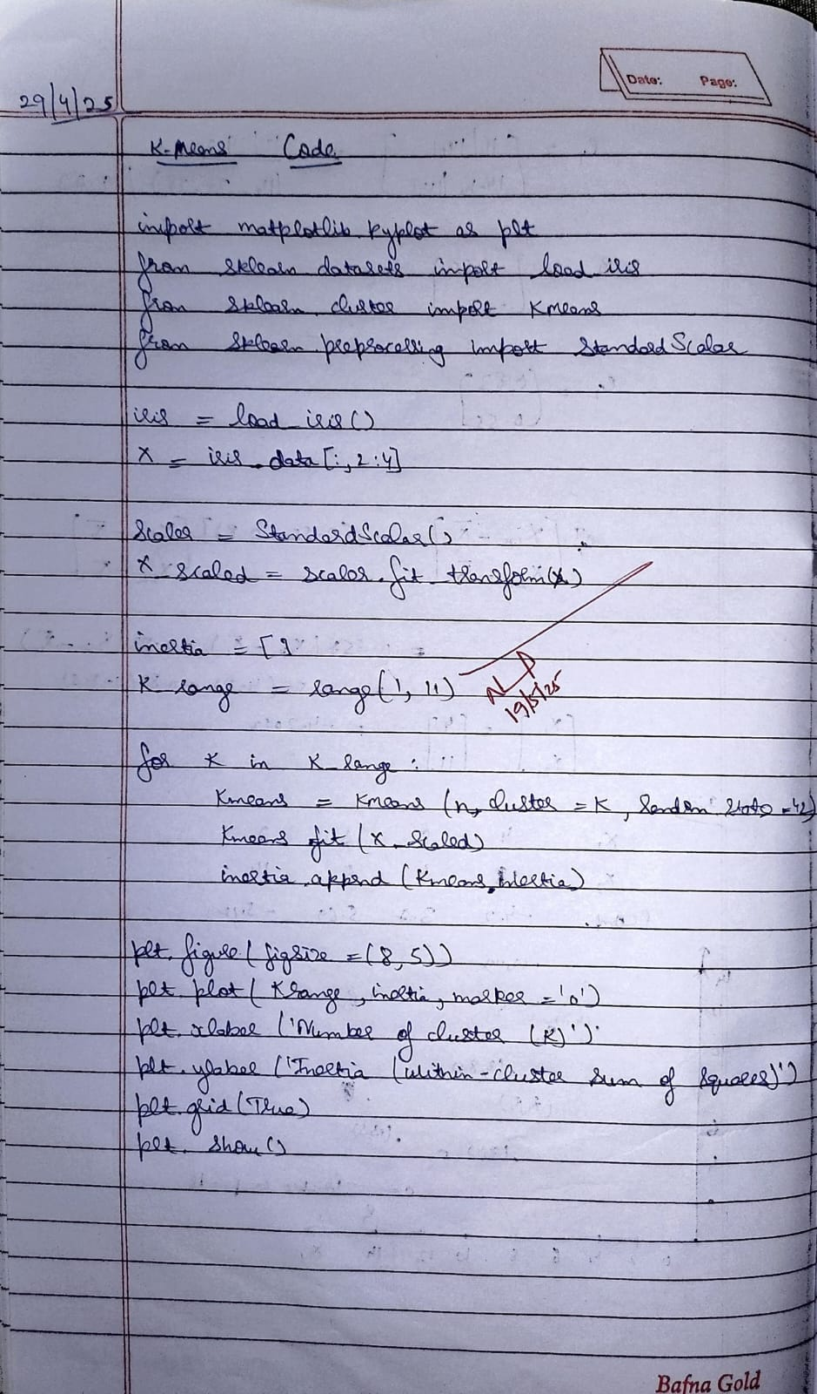

**Code:**

**Income.csv**

import pandas as pd

import numpy as np

from sklearn.model_selection import train_test_split

from sklearn.preprocessing import StandardScaler

from sklearn.cluster import KMeans

from sklearn.metrics import adjusted_rand_score

import matplotlib.pyplot as plt

import random

np.random.seed(42)

names = [f"Person_{i}" for i in range(1, 51)]

ages = np.random.randint(20, 60, 50)

incomes = np.random.randint(20000, 100000, 50)

df = pd.DataFrame({

    'Name': names,

    'Age': ages,

    'Income': incomes

})

df.to_csv('income.csv', index=False)

print("‘income.csv' created successfully.")

from google.colab import files

files.download('income.csv')

data = pd.read_csv('income.csv')

X = data[['Age', 'Income']]

X_train, X_test = train_test_split(X, test_size=0.2, random_state=42)

scaler = StandardScaler()

X_train_scaled = scaler.fit_transform(X_train)

X_test_scaled = scaler.transform(X_test)

sse = []

k_range = range(1, 11)

for k in k_range:

    kmeans = KMeans(n_clusters=k, random_state=42)

    kmeans.fit(X_train_scaled)

    sse.append(kmeans.inertia_)

plt.plot(k_range, sse, marker='o')

plt.xlabel('Number of Clusters')

plt.ylabel('SSE (Inertia)')

plt.title('Elbow Method: SSE vs Number of Clusters')

plt.grid(True)

plt.show()

k = 3  *# Change this based on the elbow plot*

model = KMeans(n_clusters=k, random_state=42)

model.fit(X_train_scaled)

train_preds = model.predict(X_train_scaled)

test_preds = model.predict(X_test_scaled)

true_labels_train = [random.randint(0, k-1) for _ in range(len(train_preds))]

accuracy = adjusted_rand_score(true_labels_train, train_preds)

print("Adjusted Rand Index (proxy accuracy):", round(accuracy, 2))

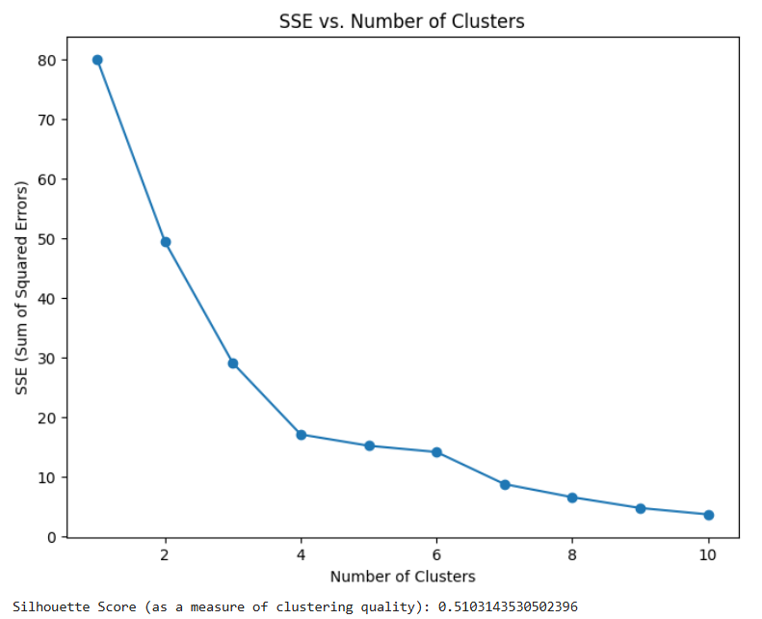

**Iris.csv**

import matplotlib.pyplot as plt

from sklearn.datasets import load_iris

from sklearn.cluster import KMeans

from sklearn.preprocessing import StandardScaler

# Step 1: Load the Iris dataset

iris = load_iris()

X = iris.data[:, 2:4] # Only petal length and width

# Step 2: Preprocessing - Scaling

scaler = StandardScaler()

X_scaled = scaler.fit_transform(X)

# Step 3: Elbow method to find optimal k

inertia = []

k_range = range(1, 11)

for k in k_range:

kmeans = KMeans(n_clusters=k, random_state=42)

kmeans.fit(X_scaled)

inertia.append(kmeans.inertia_)

# Step 4: Plot the elbow curve

plt.figure(figsize=(8, 5))

plt.plot(k_range, inertia, marker='o')

plt.xlabel('Number of Clusters (k)')

plt.ylabel('Inertia (Within-cluster sum of squares)')

plt.title('Elbow Method for Optimal k')

plt.grid(True)

plt.show()

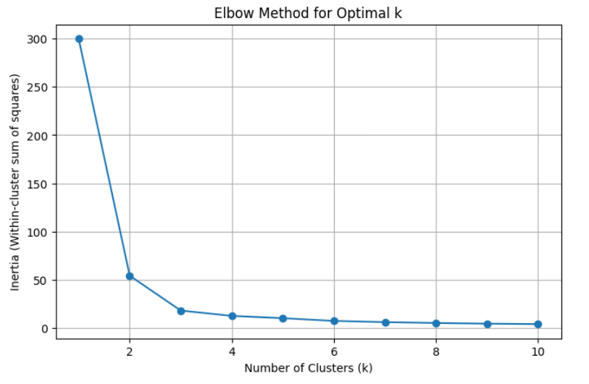

**Program 11**

**Implement Dimensionality reduction using Principal Component Analysis (PCA) method.**

**Screenshot:**

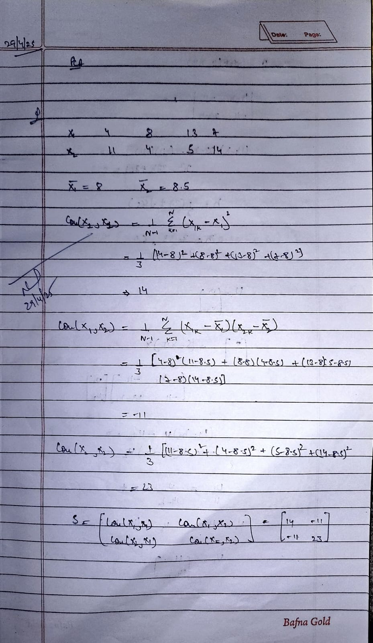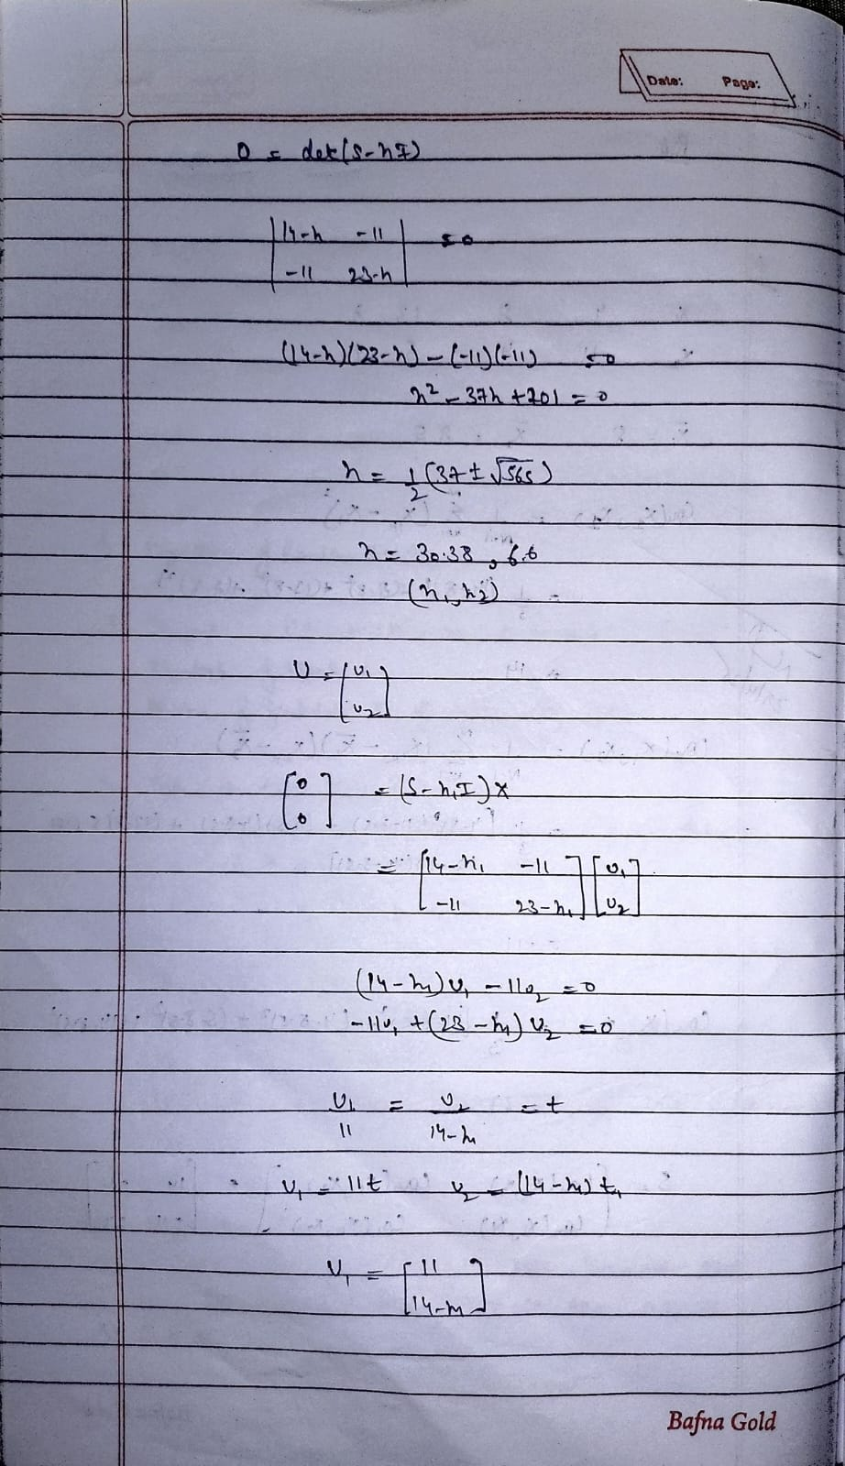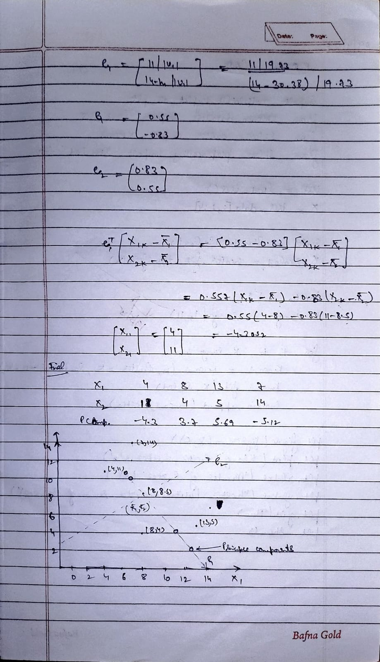

**Code:**

# Import required libraries

import numpy as np

from sklearn.datasets import load_digits

from sklearn.decomposition import PCA

from sklearn.model_selection import train_test_split

from sklearn.preprocessing import StandardScaler

from sklearn.linear_model import LogisticRegression

from sklearn.metrics import accuracy_score

# Step 1: Load the digits dataset

digits = load_digits()

X = digits.data

y = digits.target

# Step 2: Split the data into 80% training and 20% testing

X_train, X_test, y_train, y_test = train_test_split(X, y, test_size=0.2, random_state=42)

# Step 3: Perform scaling (standardization)

scaler = StandardScaler()

X_train_scaled = scaler.fit_transform(X_train)

X_test_scaled = scaler.transform(X_test)

# Step 4: Build PCA model with n_components = 2

pca = PCA(n_components=2)

X_train_pca = pca.fit_transform(X_train_scaled)

X_test_pca = pca.transform(X_test_scaled)

# Step 5: Train a Logistic Regression model

logreg = LogisticRegression(max_iter=10000)

logreg.fit(X_train_pca, y_train)

# Step 6: Predict on the test set

y_pred = logreg.predict(X_test_pca)

# Step 7: Calculate the accuracy score

accuracy = accuracy_score(y_test, y_pred)

print(f"Accuracy score using PCA with 2 components: {accuracy}")



**Heart.csv**

import pandas as pd

import numpy as np

from sklearn.preprocessing import StandardScaler

from sklearn.model_selection import train_test_split

from sklearn.linear_model import LogisticRegression

from sklearn.svm import SVC

from sklearn.ensemble import RandomForestClassifier

from sklearn.decomposition import PCA

from sklearn.metrics import accuracy_score

from scipy.stats import zscore

# Step 1: Load dataset

df = pd.read_csv("heart.csv") # Update path if needed

# Step 2: Remove outliers using Z-score

z_scores = np.abs(zscore(df.select_dtypes(include=[np.number])))

df_no_outliers = df[(z_scores < 3).all(axis=1)]

# Step 3: Convert text to numbers (if needed)

df_encoded = pd.get_dummies(df_no_outliers, drop_first=True)

# Step 4: Apply scaling

scaler = StandardScaler()

target_col = 'HeartDisease' # Update if different

X = df_encoded.drop(target_col, axis=1)

y = df_encoded[target_col]

X_scaled = scaler.fit_transform(X)

# Step 5: Train-test split

X_train, X_test, y_train, y_test = train_test_split(X_scaled, y, test_size=0.2, random_state=42)

# Step 5a: Train multiple models and compare

models = {

'Logistic Regression': LogisticRegression(max_iter=1000),

'SVM': SVC(),

'Random Forest': RandomForestClassifier()

}

print("=== Accuracy without PCA ===")

for name, model in models.items():

model.fit(X_train, y_train)

y_pred = model.predict(X_test)

acc = accuracy_score(y_test, y_pred)

print(f"{name}: {acc:.4f}")

# Step 6: PCA for dimensionality reduction

pca = PCA(n_components=2)

X_pca = pca.fit_transform(X_scaled)

X_train_pca, X_test_pca, y_train_pca, y_test_pca = train_test_split(X_pca, y, test_size=0.2, random_state=42)

print("\n=== Accuracy with PCA (2 components) ===")

for name, model in models.items():

model.fit(X_train_pca, y_train_pca)

y_pred = model.predict(X_test_pca)

acc = accuracy_score(y_test_pca, y_pred)

print(f"{name}: {acc:.4f}")

